 |   NSW Department of Education 90333 STUDENT GUIDE

CONSTRUCTION “TASK 5.3 – JOINERY” WORKBOOK
TABLE OF CONTENTS
Section 1 – Introduction to Joinery Work
Section 2 – WHS, PPE and Workplace Safety
Section 3 – Joinery Materials and Components
Section 4 – Joinery Tools, Equipment and Machinery
Section 5 – Reading Plans, Measuring and Marking
Section 6 – Manufacturing Joinery Components
Section 7 – Joinery Assembly Techniques
Section 8 – Assembly Processes
Section 9 – Fasteners, Adhesives and Hardware
Section 10 – Quality Checks, Packaging and Finishing
Section 11 – Cleaning, Storage and Waste Management
Using This Guide
This Guide includes:
subsections of information specific links to the Task 5.3 assessment activities embedded student questions
🔗 links to supporting information

This structure allows you to highlight essential knowledge while giving students chances to practise explaining processes, preparing them for both written and practical assessments.
______________________________________________________________________________ CONSTRUCTION “TASK 5.3 – JOINERY” WORKBOOK — SECTION 1
1.1 Introduction to Joinery Work
Joinery involves manufacturing, assembling and installing timber and manufactured board products used in residential and commercial construction. Joinery workers produce a wide range of items including cabinetry, shelving, doors, windows, cupboards, counters and built-in furniture.
Joinery work requires:
- planning

- accurate measuring
- safe machinery operation
- attention to detail
- correct assembly methods
- quality control
Joinery activities may be completed:
- in workshops
- on construction sites
- in factories
- during renovation work
- during fit-outs
Poor joinery practices may result in:
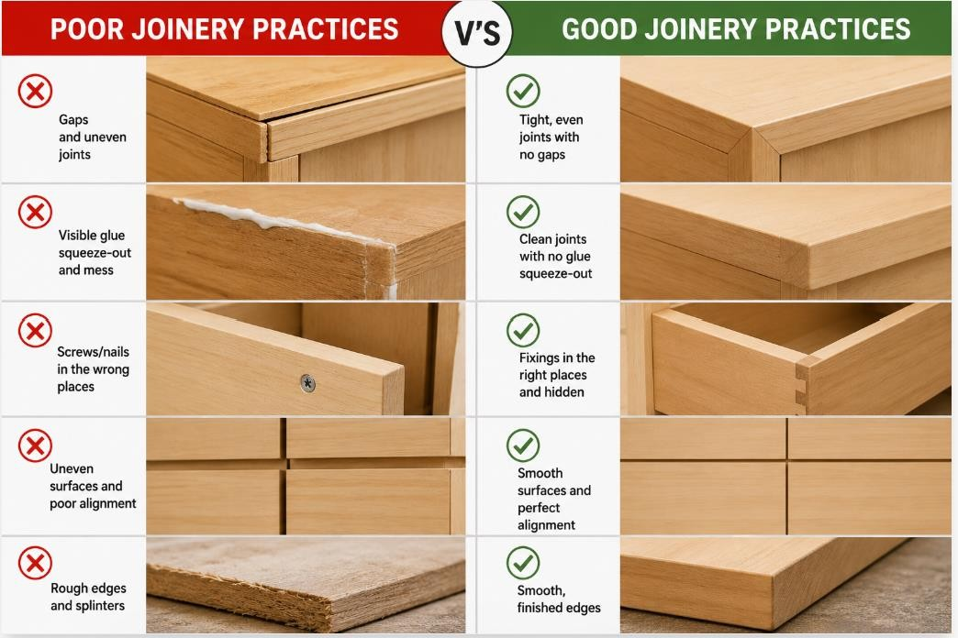
- damaged materials
- unsafe assemblies
- poor alignment
- weak joints
- operational problems
- expensive rework
Good joinery practices improve:
- product quality
- durability
- safety
- appearance
- customer satisfaction
🔗 The Importance of Joinery in Long-Lasting Projects (Joinery Essentials)

1.2 Types of Joinery Work
Joinery workers may complete a range of residential and commercial projects requiring different materials, hardware and assembly methods.

Joinery work may include:
- kitchen cabinetry
- wardrobes
- shelving
- vanities
- benchtops
- doors
- windows
- shopfronts
- stair components
- office fit-outs
Different joinery products require different:
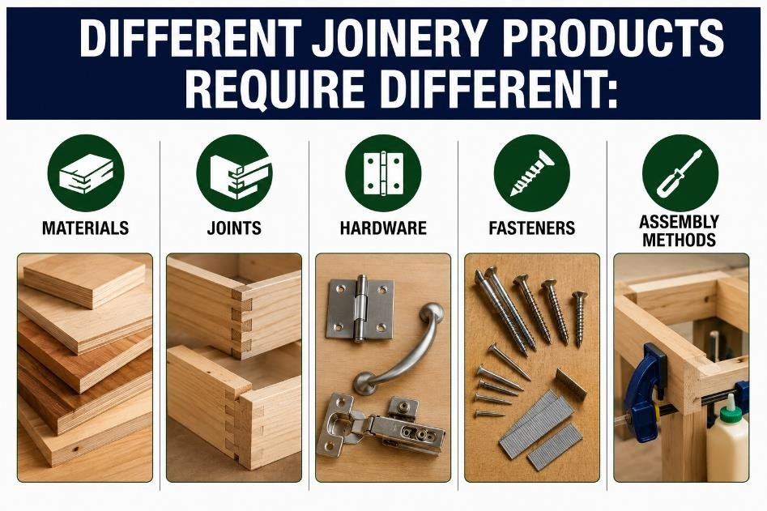
- materials
- joints
- hardware
- fasteners
- assembly methods

STUDENT QUESTIONS
What types of products may joinery workers manufacture?
Your Answer:

Name two reasons why good joinery practices are important?
Your Answer:

1.3 Workplace Procedures
Workers are expected to follow workplace procedures and maintain safe, organised and professional work practices.
Workers may be required to follow:
- Job Safety Analyses (JSAs)
- Safe Operating Procedures (SOPs)
- Environmental Management Plans
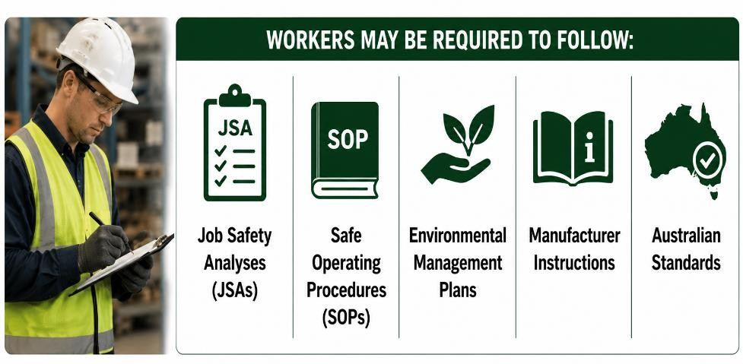
- manufacturer instructions
- Australian Standards
These documents help ensure:
- safe work practices
- correct installation methods
- consistent quality
- environmental compliance
In the workplace, workers are expected to:
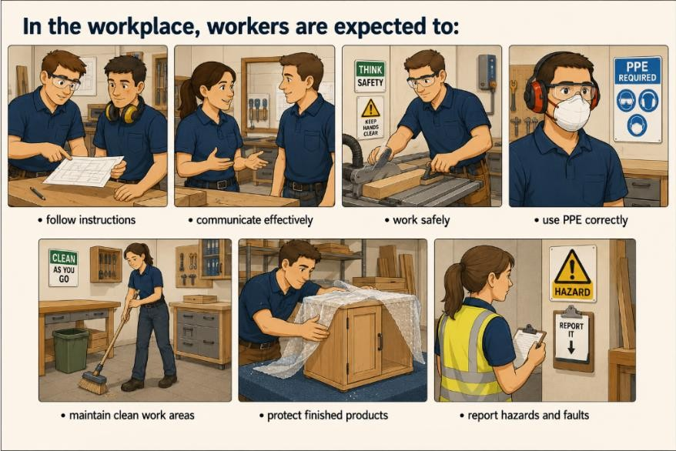
- follow instructions
- communicate effectively
- work safely
- use PPE correctly
- maintain clean work areas
- protect finished products
- report hazards and faults Workers should:
- cooperate with others
- respect workplace rules
- follow manufacturer instructions
- complete tasks to workplace quality standards
🔗 New Place Construction Employee Handbook
In Task 5.3 – Section 3 practical observations, students must follow and meet workplace standards during practical activities.
STUDENT QUESTION
Why is communication important during joinery work?
Your Answer:

1.4 Joinery Standards
Australian Standards (AS) provide nationally recognised requirements for safety, quality, manufacturing and installation within the construction and joinery industries. These standards help ensure joinery products are manufactured safely, operate correctly and meet workplace and industry expectations.
Common Australian Standards relevant to joinery work include:
Australian Standard (AS) | Description
AS 4386:2018 Cabinetry in the builtin environment - Commercial and domestic | Specifies the minimum installation requirements for domestic pre-assembled or flat pack kitchen assemblies
AS 4386.1 Domestic kitchen assemblies - kitchen units | Specifies requirements for the guarding and use of wood processing machinery (plant) for the processing joinery materials
AS 4386.2 Domestic kitchen assemblies - installation | Specifies requirements for adhesives suitable for use in the plywood and laminated veneer lumber (LVL) manufacturing industry
AS 1473.2-2001 Wood processing machinery - Safety | Specifies requirements for the manufacture and installation of kitchens and built-in furniture
AS/NZS 2754.1:2016 Adhesives for timber and timber products | Specifies the minimum requirements for the construction of kitchen assemblies used in domestic applications
AS 1859.1:2017 Reconstituted wood-based panels - Specifications | Specifies requirements for building practice and the selection, placement and fixing of the various structural elements used in the construction of timber-framed buildings
AS 1684.2:2021 Residential timberframed construction | Specifies performance requirements for the manufacture and application of particleboard
🔗 NSW guide to standards and tolerances 2017
Task 5.3 – quiz questions assess a student’s ability to match joinery industry standards to their purpose. In Section 3 practical observations, students access and review the WHS requirements and guarding information in the AS 1473.2 - 2001 Wood processing machinery - Safety, for machinery to be used.
STUDENT QUESTION
Why are Australian Standards important?
Your Answer:

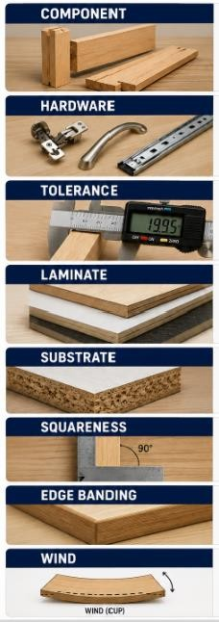
1.5 Joinery Terminology
Component
An individual part used in the assembly of a joinery product.
Hardware
Fittings such as hinges, handles and drawer runners.
Tolerance
The acceptable variation from a specified measurement.
Laminate
A decorative protective surface bonded to a board product.
Substrate
The base material underneath a finish or laminate.
Squareness
The condition of corners forming accurate 90-degree angles.
Edge Banding
Protective edging applied to exposed board edges.
Wind
A twist in an assembly causing corners to become uneven.
Datum Edge
The reference edge from which measurements and dimensions are consistently taken from.
Grain Direction
The direction in which the wood fibres run, affecting the strength, appearance and machining.
Cupping
A timber defect where the board curves across its width, creating a hollow or convex surface.
Bow
A timber defect where the board curves along its length, causing the faces to become uneven.
STUDENT QUESTION
Why is squareness important in joinery work?
Your Answer:

What is edge banding used for? Your Answer:

What does “wind” mean in a joinery assembly?
Your Answer:
CONSTRUCTION “TASK 5.3 – JOINERY” WORKBOOK — SECTION 2
WHS, PPE and Workplace Safety
2.1 WHS Responsibilities
Joinery work involves hazards associated with machinery, tools, dust, manual handling and chemicals. Workers must follow workplace health and safety procedures at all times.
Workers must:
  - follow workplace procedures
  - wear PPE
  - report hazards
  - use machinery safely
  - maintain clean work areas Supervisors and employers must:
  - provide training
  - maintain equipment
  - provide safe systems of work
  - supervise workers appropriately
🔗 Worker Obligations
🔗 Your Rights at Work
Task 5.3 – quiz questions assess a student’s ability to identify WHS requirements. In Section 3 practical observations, students must identify joinery hazards and follow control measures to reduce the likelihood of an accident and/or injury.
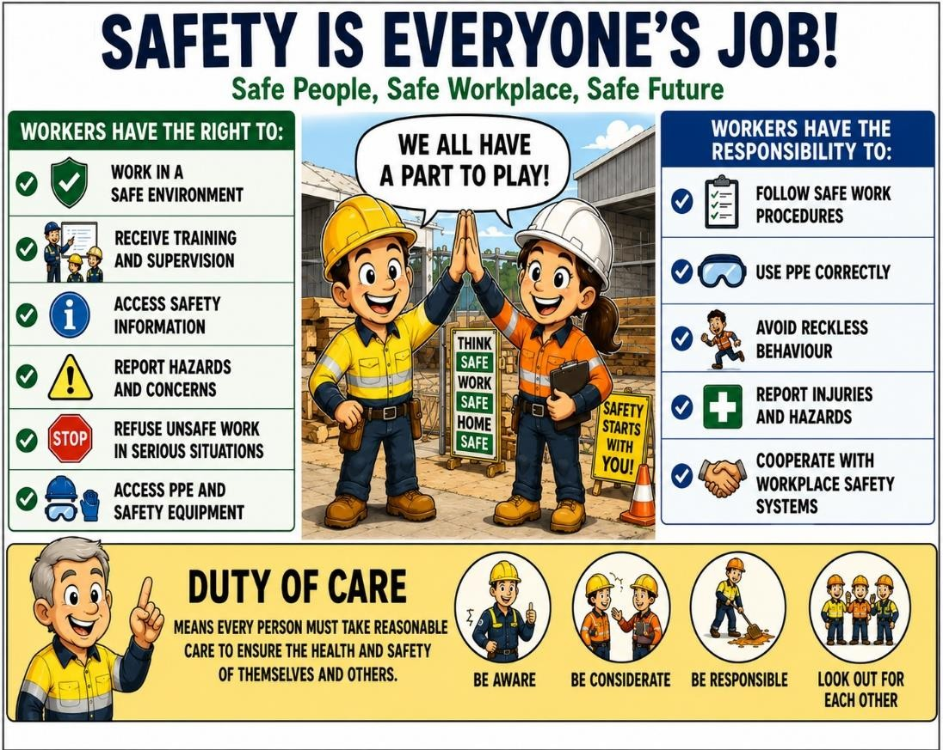

2.2 Communication and Reporting
Workers must communicate clearly with supervisors and other workers during joinery activities.
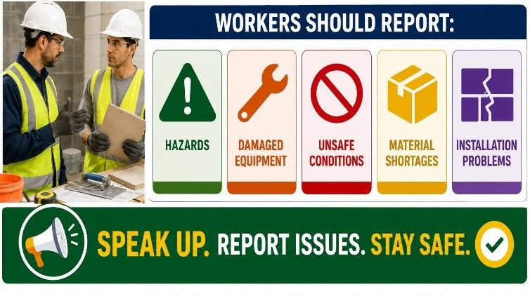
Workers should report:
  - hazards
  - damaged equipment
  - unsafe conditions
  - material shortages
  - installation problems
Clear communication helps maintain safety, workflow and work quality.
In Task 5.3 – Section 2 students must complete a Work Plan with Job Safety Analysis (JSA).

2.3 PPE Requirements
Personal protective equipment (PPE) helps reduce the risk of injuries during joinery work.
Common PPE in used during joinery work includes:
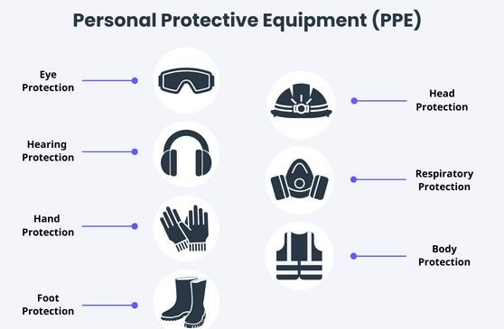
  - safety glasses
  - hearing protection
  - steel-capped boots
  - high-visibility clothing
  - dust masks or respirators
  - gloves
Additional PPE may be required when:
  - sanding and cutting
  - using adhesives
  - operating machinery
🔗PPE and PPE Video
In Task 5.3 – Section 3 practical observations, students must select and use PPE during practical joinery activities.
STUDENT QUESTION
Why is hearing protection important in joinery workshops?
Your Answer:

2.4 Hierarchy of Hazard Controls
The hierarchy of control is used to determine the most effective methods for reducing workplace risks.
Levels of control include:
  - Elimination - remove damaged machinery from use
  - Substitution - use water-based adhesive instead of solvent-based adhesive
  - Isolation - separate machinery area with barriers
  - Engineering controls - machine guards and dust extraction systems
  - Administrative controls - JSA, safety signage and worker training
  - PPE - safety glasses, hearing protection and dust masks
🔗 Hierarchy of Risk Control
🔗 The Hierarchy of Controls Video
Task 5.3 – quiz questions assess a student’s ability to identify levels and examples of hazard controls.
STUDENT QUESTION
What type of control is a machine guard?
Your Answer:
An engineering control.

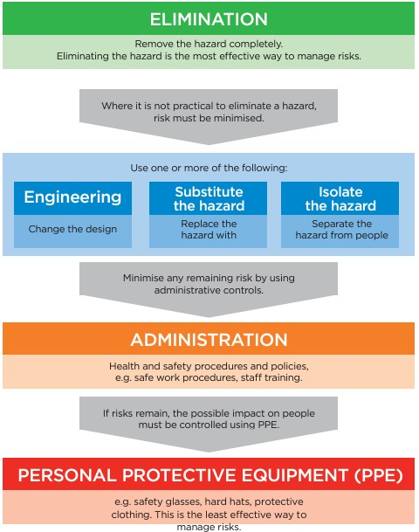

2.5 Mechanical and Non-Mechanical Hazards
Workers must identify and control both mechanical and non-mechanical hazards before beginning work activities.
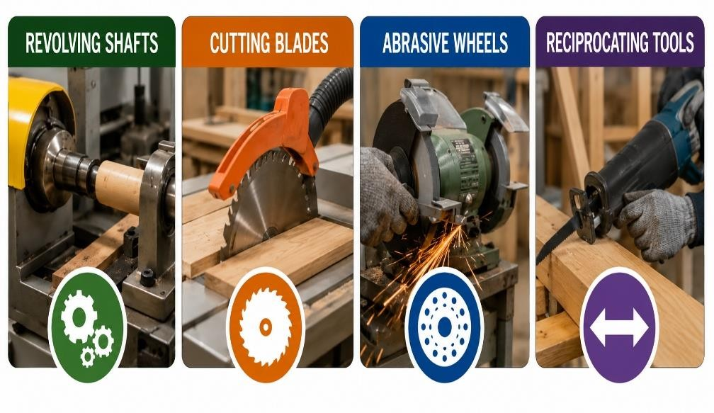
Mechanical hazards
Mechanical hazards involve moving machinery parts.
Joinery related examples include:
  - revolving shafts
  - cutting blades
  - abrasive wheels
  - reciprocating tools
Non-mechanical hazards
Non-mechanical hazards are hazards not directly caused by machinery movement.
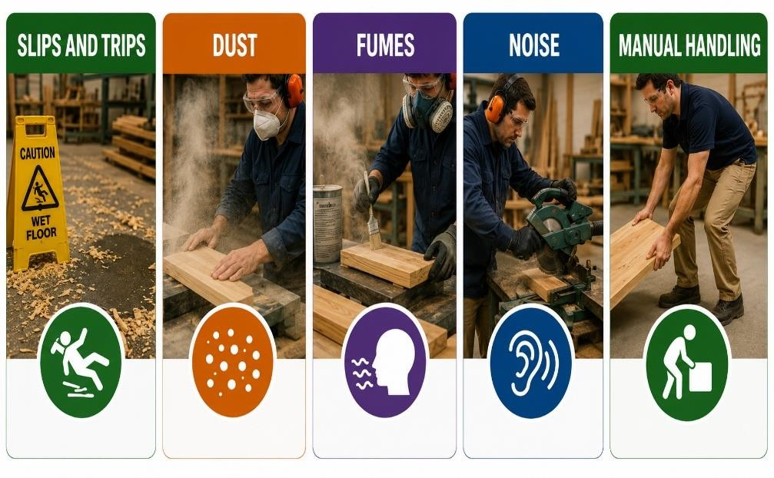
Joinery related examples include:
  - slips and trips
  - dust
  - fumes
  - noise
  - manual handling
🔗 Hazards A-Z
🔗 Interactive Hazards
🔗 Site Housekeeping
Task 5.3 – quiz questions and Section 2 Work Plan (JSA) assess a student’s ability to identify mechanical and non-mechanical hazards. In Section 3 practical observations, students must follow control measures to reduce the likelihood of a joinery accident and/or injury.
STUDENT QUESTION
Give one example of a mechanical hazard and one example of a non-mechanical hazard.
Your Answer:

2.6 WHS Documentation
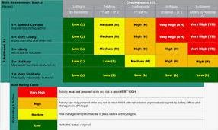
Workers must understand and follow various WHS documentation to reduce the likelihood of an accident and injury.
Examples include:
  - Job Safety Analysis (JSA)
  - Safe Work Method Statements (SWMS)
  - Safety Data Sheets (SDS)
  - Safe Operating Procedures (SOP)
  - incident reports
  - induction records
JSA
Identifies hazards and safe work procedures for general activities.
SWMS
Outlines hazards and controls for high-risk construction work.
SDS
Provides safety information about hazardous substances and chemicals.
Workers must understand workplace documentation before beginning work.
🔗 JSA Example
🔗 How to Complete a JSA
🔗 SWMS Templates
🔗 SWMS Example
🔗 SDS Example
Task 5.3 – quiz questions assess a student’s ability to identify WHS documentation. In Task
Section 2 students must complete a Job Safety Analysis (JSA) for each practical project. In Section 3 practical observations, students access and review the WHS requirements and guarding information in the SOP for machinery to be used.

2.7 Environmental Considerations
Environmental considerations and controls are very important while undertaking joinery work.

Examples include:
- reducing waste
- recycling materials
- controlling dust
- reducing noise
- safe chemical storage
- preventing stormwater contamination
The NSW EPA (Environment Protection Authority) regulates environmental protection requirements.
Task 5.3 – quiz questions assess a student’s ability to identify environmental considerations and procedures joinery workers should understand and follow.
For further environmental consideration information refer to Section 11 of this guide.

2.8 Manual Handling
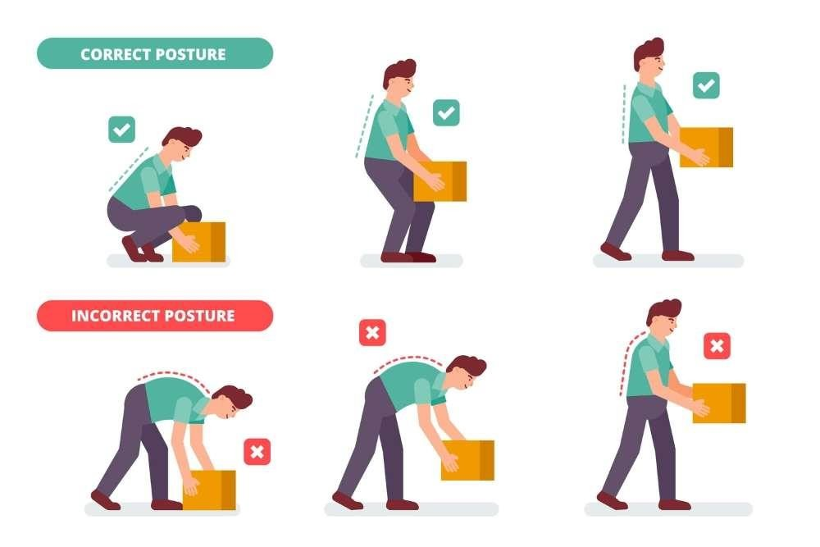
Joinery materials such as MDF sheets and benchtops may be heavy or awkward. Safe manual handling techniques help reduce the risk of strain and injury when moving materials and equipment.
Safe manual handling techniques include:
- bending knees
- team lifting
- using trolleys
- avoiding twisting
Incorrect lifting may cause:
- back strain
- muscle injuries
- fatigue
🔗 Hazardous Manual Tasks
In Task 5.3 – Section 3 practical observations, students safely handle, prepare and position practical project materials and hardware ready for use.
STUDENT QUESTION
When should team lifting be used?
Your Answer:

CONSTRUCTION “TASK 5.3 – JOINERY” WORKBOOK — SECTION 3
Joinery Materials and Components
3.1 Common Joinery Materials
Joinery products are manufactured using a range of timber and manufactured board materials.
Common joinery related materials include:
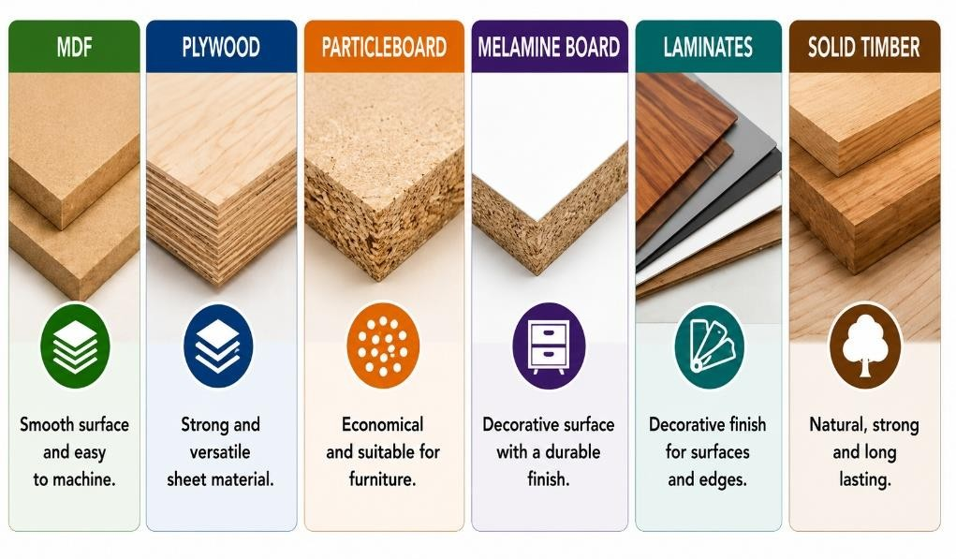
- MDF
- plywood
- particleboard
- melamine board
- laminates
- solid timber
Different materials are selected depending on:
- moisture exposure
- strength
- appearance
- budget
- finish requirements
In Task 5.3 – Section 2 Work Plan, students must complete a Materials List for each practical project they produce.
STUDENT QUESTION
Why may different material products used for different projects?
Your Answer:
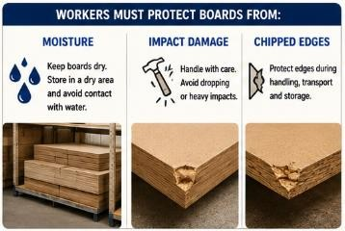

3.2
Manufactured Boards

Manufactured boards provide:

•

smooth surfaces

•

consistent sizing

•

easy machining

•

cost efficiency

Workers must protect boards from:

•

moisture

•

impact damage

•

chipped edges

  - Hardware and Fittings
Hardware and fittings allow joinery products to operate correctly and securely.
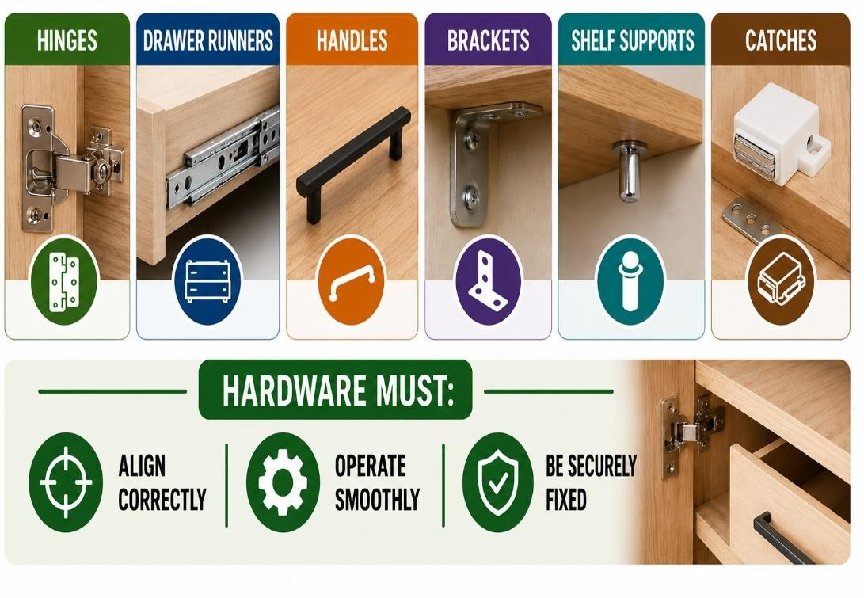
Joinery products commonly
use
d for joinery work include
:

•

hinges

•

drawer runners

•

handles

•

brackets

•

shelf supports

•

catches

Hardware must:

•

align correctly

•

operate smoothly

•

be securely fixed

  - Door and Window Components
Joinery workers may undertake the manufacture of:
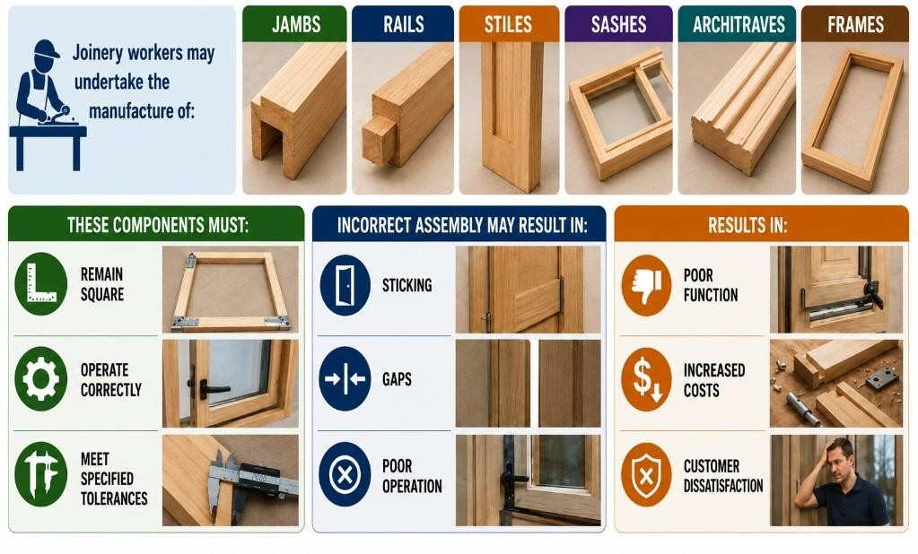
- jambs
- rails
- stiles
- sashes
- architraves
- frames
These components must:
- remain square
- operate correctly
- meet specified tolerances
Incorrect assembly may result in:
- sticking
- gaps
- poor operation
In Task 5.3 – Section 3 practical observations, students must produce a multi panelled door.
STUDENT QUESTION
What may happen if door assemblies are not square?
Your Answer:
3.5 Inspecting Materials and Components
Materials and components should be inspected before use to identify defects or damage.

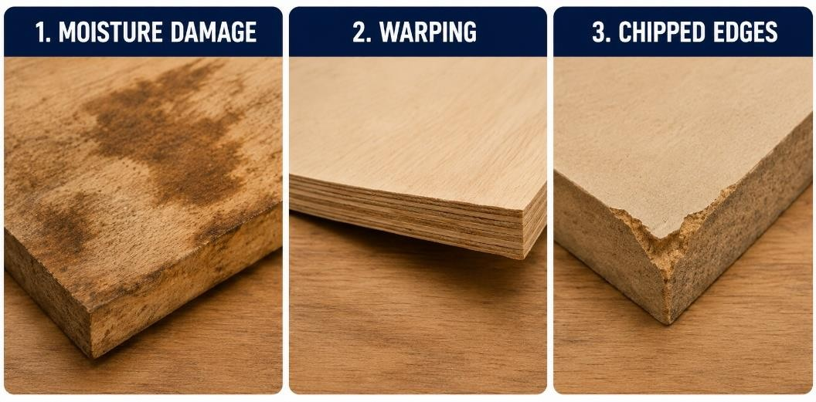
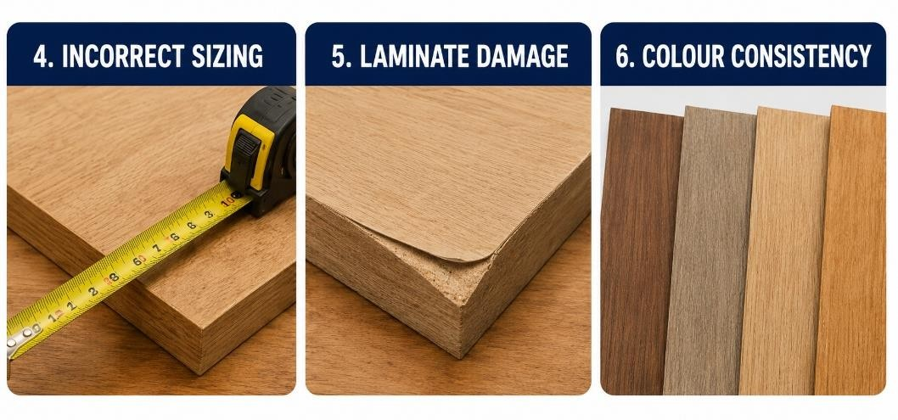
Checks may include:
- moisture damage
- warping
- chipped edges
- incorrect sizing
- laminate damage
- colour consistency
Defective materials may affect:
- assembly quality
- appearance
- durability

🔗 NSW guide to standards and tolerances 2017
Task 5.3 – quiz questions assess a student’s ability to identify project quality control check processes. In Section 3 practical observations, students must undertake quality checks of project materials and components.
STUDENT QUESTION
Why should materials be inspected before use?
Your Answer:

CONSTRUCTION “TASK 5.3 – JOINERY” WORKBOOK — SECTION 4
Joinery Tools, Equipment and Machinery
4.1 Hand Tools
Joinery workers use a range of hand tools during manufacturing and assembly activities.
Common hand tools used during joinery work include:
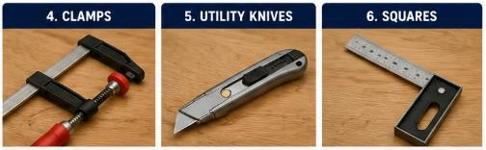
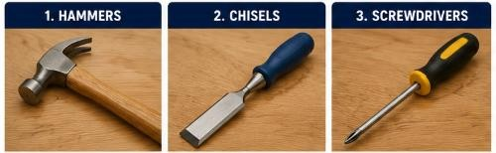
- hammers
- chisels
- screwdrivers
- clamps
- utility knives
- squares Workers must:
- inspect tools before use
- store tools safely
- maintain sharp edges
🔗 Various Hand Tools and Introduction to Hand Tools

4.2 Portable Power Tools
Portable power tools improve efficiency and assist workers with cutting, drilling and finishing tasks.
Portable power tools used during joinery work may include:
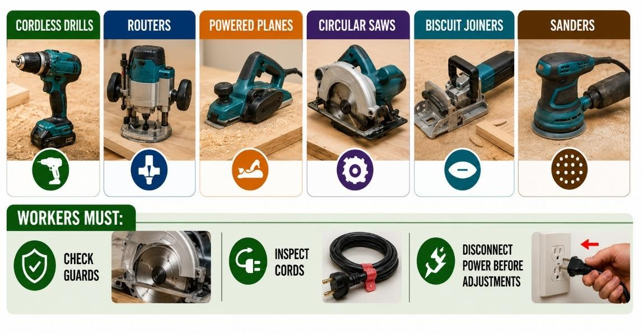
- cordless drills
- routers
- powered planes
- circular saws
- biscuit joiners
- sanders Workers must:
- check guards
- inspect cords
- disconnect power before adjustments
🔗 Power Tool Safety
STUDENT QUESTION
Why should guards be checked before using power tools?
Your Answer:
4.3 Fixed Machinery
Fixed workshop machinery is commonly used to cut, shape and machine joinery materials accurately.
Common workshop machinery used during joinery work includes:
- table saws
- drop saws
- thicknessers
- morticing machines
- drill presses Workers must:
- follow SOPs
- use guards
- maintain safe hand positions
- isolate machinery before maintenance
🔗 Machinery and Equipment A-Z
For more detailed tools and machinery information refer to the Task 2 - Tools and Equipment - Teacher Guide.
Task 5.3 – quiz questions assess a student’s ability to identify various joinery hand and power tools, their use and safety measures. In Section 3 practical observations, students must select and use joinery machinery, hand and power tools safely.
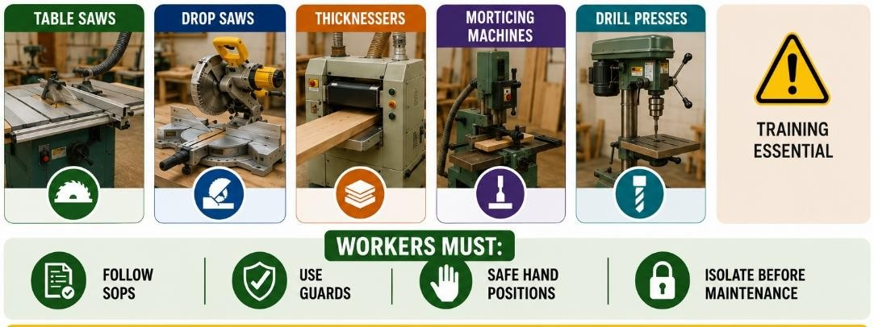

4.4 Measuring and Marking Tools
Accurate measuring and marking are essential for quality joinery manufacturing and assembly.
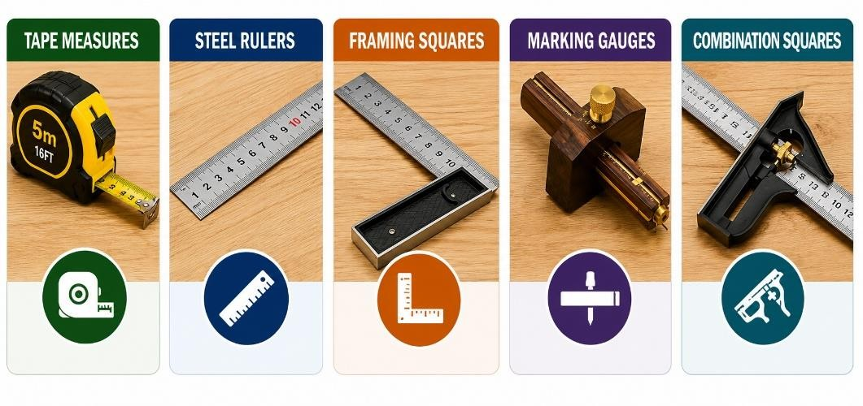
Examples include:
- tape measures
- steel rulers
- framing squares
- marking gauges
- combination squares
Accurate measuring improves:
- fit
- squareness
- assembly quality
🔗 Measuring, Marking and Cutting Timber, Reading a Tape Measure Picture, Video 1 & Video 2
In Task 5.3 – Section 3 practical observations, students must use various tools to measure, mark and check practical project material and component dimensions.
STUDENT QUESTION
Why is accurate measuring important in joinery work?
Your Answer:

4.5 Pre-Operational Checks
Workers should inspect machinery and equipment before use to identify faults or hazards.
Before using tools, equipment and machinery, workers should check:
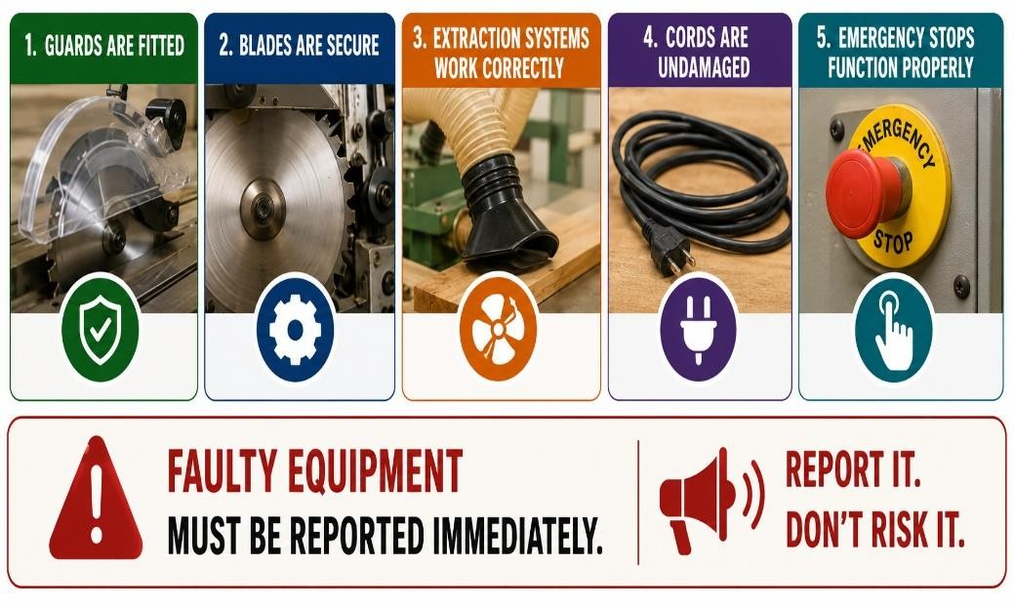
- guards are fitted
- blades are secure
- extraction systems work correctly
- cords are undamaged
- emergency stops function properly
Faulty equipment must be reported immediately.

In Task 5.3 – Section 3 practical observations, students must complete pre-operational checks on machinery, tools and equipment selected for the practical joinery projects.
4.6 Electrical Safety Basics
Workers must be able to explain and apply electrical safety concepts, including:
- never use damaged leads or tools
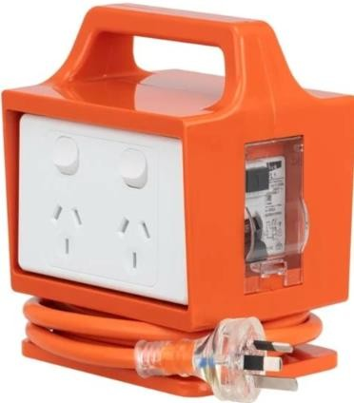
- test and tag requirements
- RCD (safety switch) use
- no piggybacking of power boards
- keep cords away from water and heat
- report frayed or exposed wiring immediately
🔗 Electrical Safety A-Z
🔗 RCD
🔗 Test and Tag

4.7 Tool Start-Up and Shut-Down Procedures
Safe start-up and shut-down procedures help reduce the risk of injury and equipment damage.
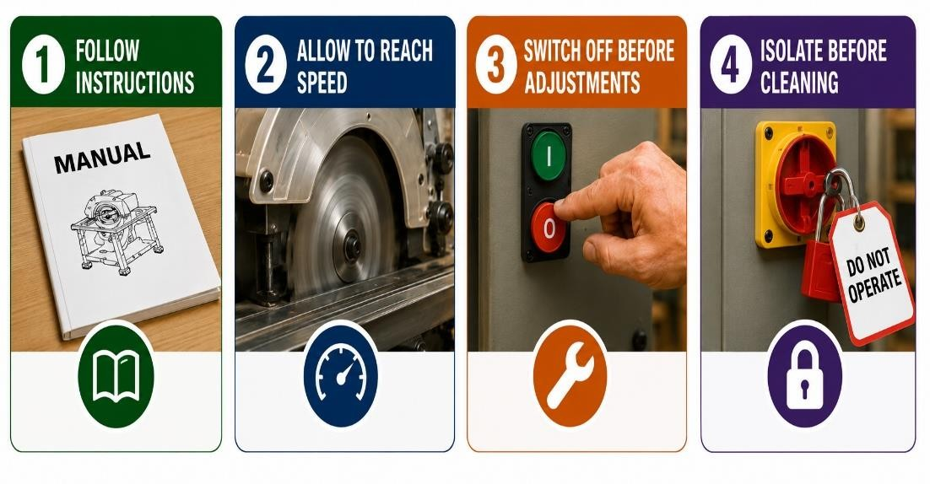
Workers must:
- follow manufacturer instructions
- allow machinery to reach operating speed
- switch machinery off before adjustments
- isolate machinery before cleaning
STUDENT QUESTION
Why should machinery be isolated before maintenance?
Your Answer:

Why should machinery reach operating speed before cutting?
Your Answer:

4.8 Clamps, Cramps and Holding Devices
Clamps and holding devices are used to temporarily secure joinery components during marking, machining and assembly. They prevent movement, improve accuracy and ensure joints remain square while adhesives cure or mechanical fasteners are installed.
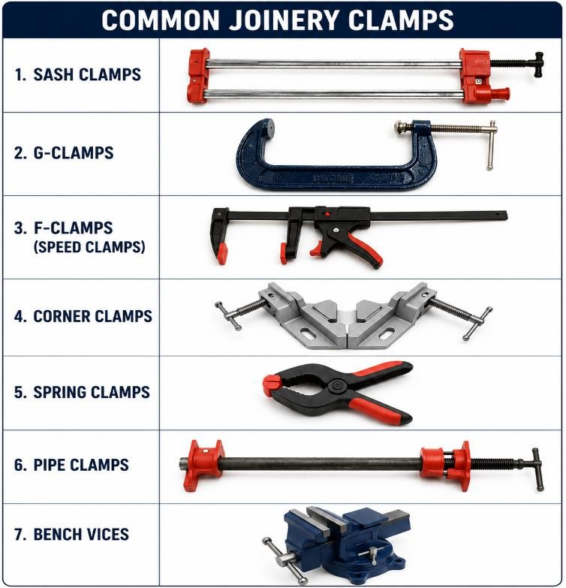
Common types of clamps include:
- Sash clamps
- G-clamps
- F-clamps (speed clamps)
- Corner clamps
- Spring clamps
- Pipe clamps
- Bench vices
Clamps are commonly used to:
- Hold workpieces securely while machining
- Keep joints aligned during assembly
- Apply even pressure while adhesives cure
- Prevent movement during drilling, routing or sanding
- Maintain square assemblies during glue-up
When using clamps, workers should:
- Position clamps evenly around the workpiece
- Use protective timber blocks where necessary to prevent marking finished surfaces
- Apply sufficient pressure without damaging the timber
- Check assemblies remain square before leaving the adhesive to cure
🔗 Clamps 1, 2, 3 and 4
Task 5.3 quiz questions assess students’ knowledge of joinery assembly equipment. In Section 3 practical observations, students use clamps and holding devices to secure components safely during machining and assembly.
STUDENT QUESTION
Why are clamps used during joinery assembly?
Your Answer:

4.9 Packers and Wedges
Packers and wedges are used during the manufacture and installation of joinery components to position, level, plumb and support assemblies before they are permanently fixed.
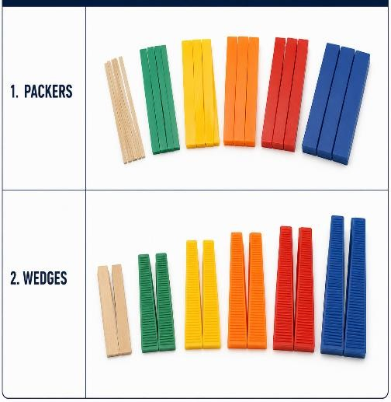
Common uses include:
- Levelling door and window frames and jambs
- Supporting cabinets and benchtops during installation
- Adjusting components to achieve plumb, level and square
Packers are manufactured in different thicknesses to provide accurate spacing, while wedges are tapered pieces used to make fine adjustments by sliding them together or apart.
When using packers and wedges, workers should:
- Select the correct thickness
- Position them securely to prevent movement
- Check assemblies remain plumb, level and square
- Remove excess wedges or trim them after installation where required
STUDENT QUESTION
What are packers and wedges used for?
Your Answer:

4.10 Presses
Presses are specialised machines used to apply controlled and even pressure during the manufacture and assembly of joinery components. They improve bond strength, maintain accurate alignment and produce consistent, high-quality finished products.
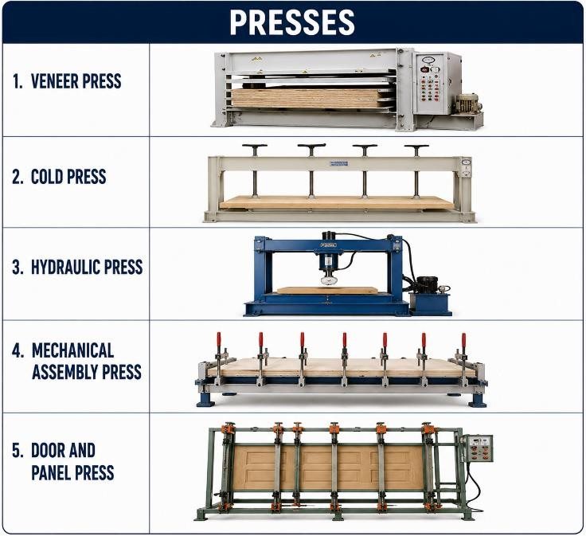
Common types of presses include:
- Veneer, cold and hydraulic presses
- Mechanical assembly presses
- Door and panel presses
Presses are commonly used to:
- Bond laminates and veneers
- Clamp large panels during glue curing
- Assemble cabinet and door components
- Apply even pressure across glued joints When using presses, workers should:
- Ensure components are correctly aligned before pressure is applied
- Allow sufficient curing time before releasing pressure
- Check the finished assembly for square and alignment after removal
CONSTRUCTION “TASK 5.3 – JOINERY” WORKBOOK — SECTION 5
Reading Plans, Measuring and Marking
5.1 Reading Plans and Specifications
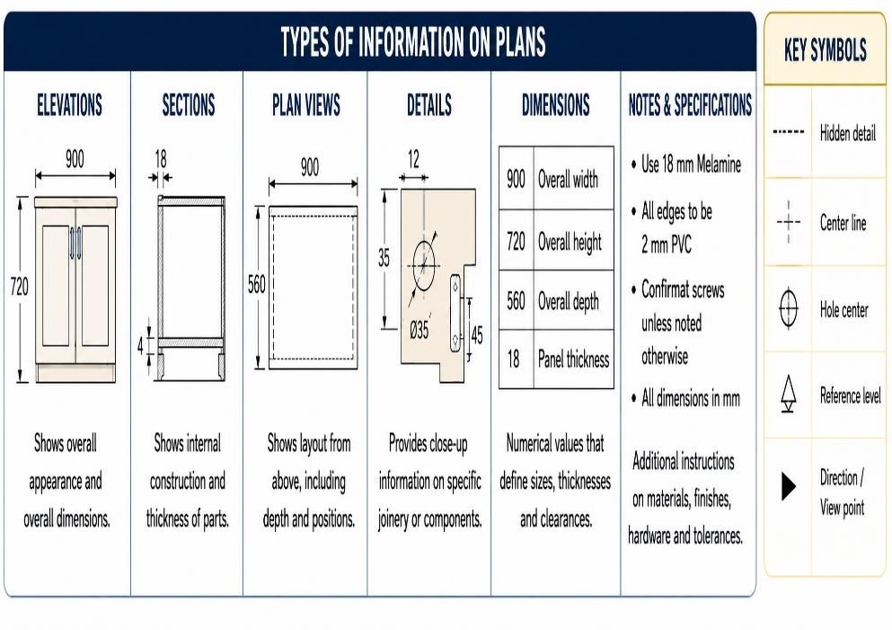
Prior to undertaking any joinery work, workers must access, read and understand the project specific plans and specifications.
Plans may show:
- dimensions
- hardware locations
- assembly details
- material requirements
- cutting sizes
Incorrect interpretation may cause:
- wasted materials
- assembly problems
- poor fit
🔗 Reading Construction Plans 1, 2 and 3
In Task 5.3 – Section 3 practical observations, students review and follow plans and specifications for the practical joinery projects.
STUDENT QUESTION
Why should workers review plans before manufacturing begins?
Your Answer:
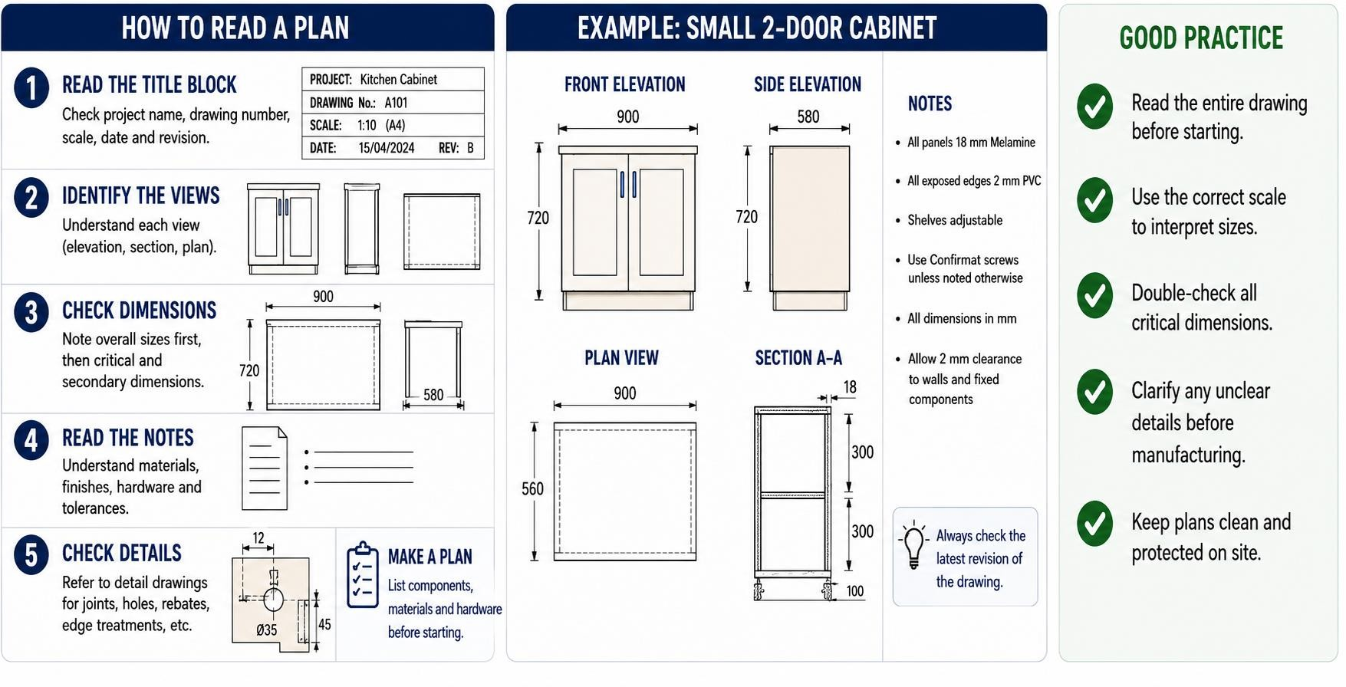

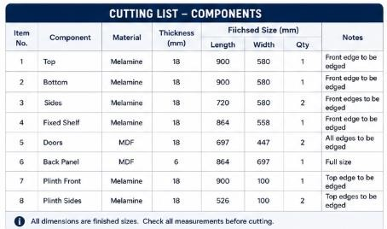
5.2 Cutting/Material Lists
Cutting or materials list identify joinery project:
- component sizes
- quantities
- material types
- edging requirements
Workers should check dimensions carefully before cutting.
🔗 Create a Material List
In Task 5.3 – Section 2 Work Plan, students must complete a Materials List for each practical project they produce.
STUDENT QUESTION
What information may be included in a cutting list?
Your Answer:

5.3 Calculating Material Quantities
Workers may calculate material quantities before manufacturing begins to improve efficiency and reduce waste.
Throughout joinery work activities, workers may be required to calculate:
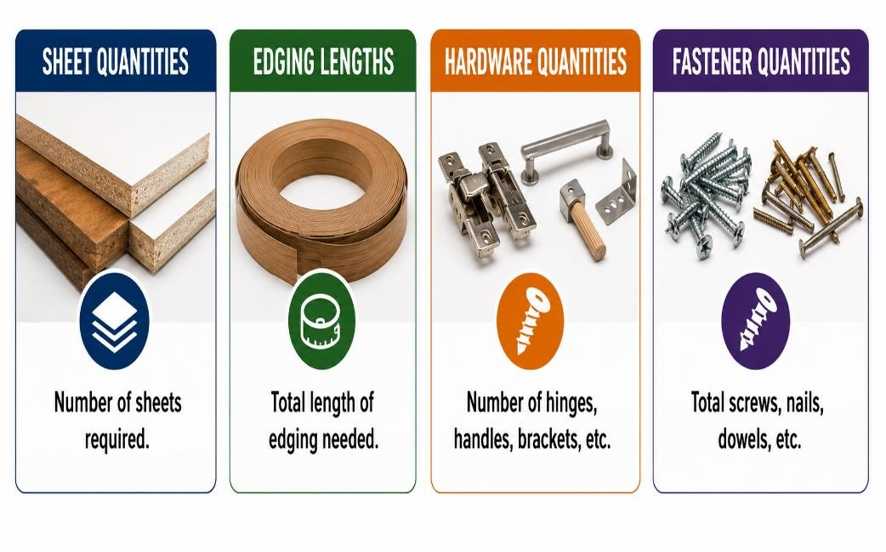
- sheet quantities
- edging lengths
- hardware quantities
- fastener quantities
Accurate calculations reduce:
- waste
- delays
- shortages
🔗 Material Calculator
🔗 Furniture Trade Math
STUDENT QUESTION
Why are tolerances important?
Your Answer:

5.4 Measuring and Marking
When preparing materials for cutting and other joinery processes, workers should:
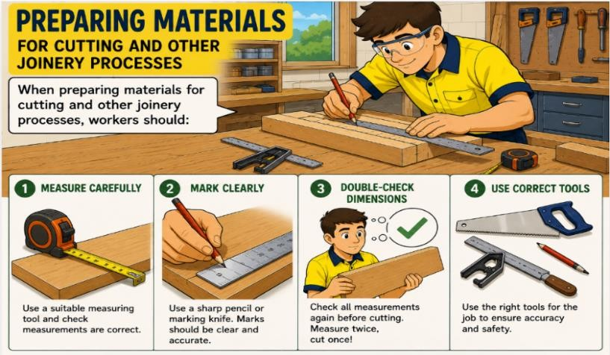
- measure and mark carefully and clearly
- double-check dimensions
- use correct tools
Small measurement errors may affect:
- alignment
- hardware positioning
- assembly quality
🔗 Measure and Mark Steps and Mark and Measure Video
In Task 5.3 – Section 3 practical observations, students must use various tools to measure, mark and check practical project material and component dimensions.
STUDENT QUESTION
Why should dimensions be double-checked before cutting?
Your Answer:
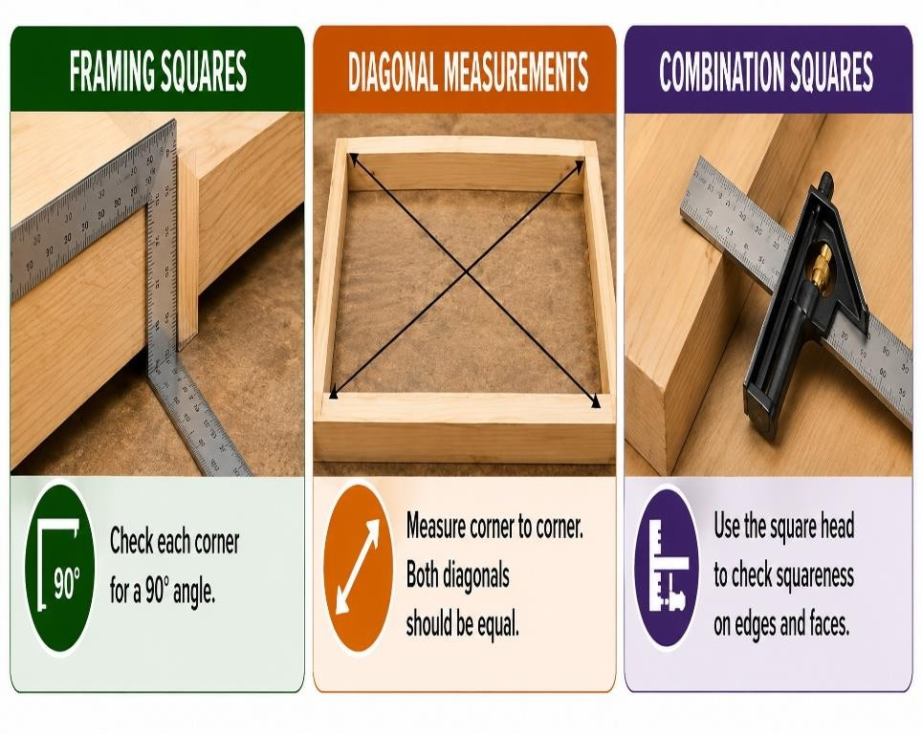

5.
5

Checking Squareness

Joinery assemblies must remain
square to fit and operate correctly.

To ensure
joinery project
components are square, w
orkers
may use:

•

framing squares

•

diagonal measurements

•

combination squares

Out
-
of
-
square assemblies may:

•

twist

•

bind

•

create gaps

In Section 3 practical observations, students check that manufactured project components are square.
STUDENT QUESTION
How could workers check squareness?
Your Answer:

5.6 Tolerances and Manufacturing Accuracy
Manufacturing tolerances help ensure components assemble correctly and meet quality standards.
Workers should regularly check:
- length
- width
- thickness
- squareness
- hole locations
Small errors may cause:
- poor alignment
- operational issues
- assembly failure
🔗 Mark and Measure Precisely
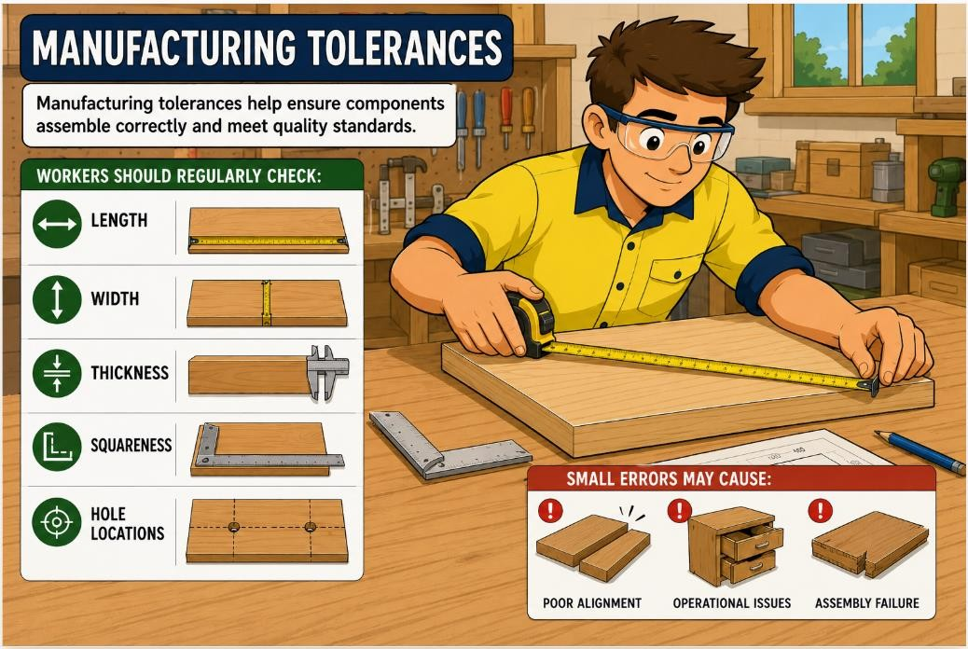
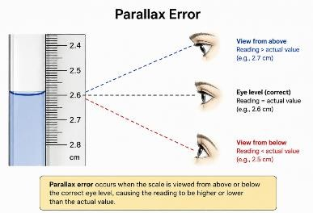
🔗 Measuring Mistakes and Fixes
🔗 NSW guide to standards and tolerances 2017

Task 5.3 –Section 3 practical observations, students must produce components within teacher designated tolerances and use measuring equipment to check the component dimensions against their project plan specifications.

CONSTRUCTION “TASK 5.3 – JOINERY” WORKBOOK — SECTION 6
Manufacturing Joinery Components
6.1 Production Sequencing
Planning manufacturing tasks in the correct order improves workflow and reduces errors.
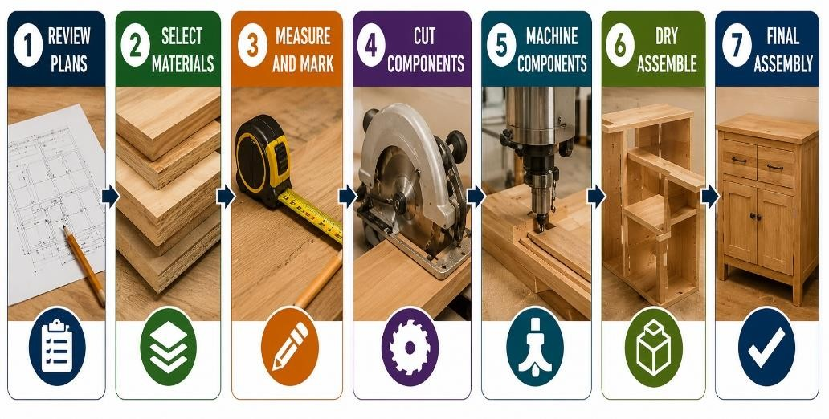
Typical sequencing may include:
- Review plans
- Select materials
- Measure and mark
- Cut components
- Machine components
- Dry assemble
- Final assembly
In Task 5.3 – Section 2 Work Plan, students must complete a Production Sequence for each practical project they produce.

6.2 Cutting Components
Components must be cut accurately according to plans, measurements and cutting lists.
While undertaking joinery work, workers may be required to:
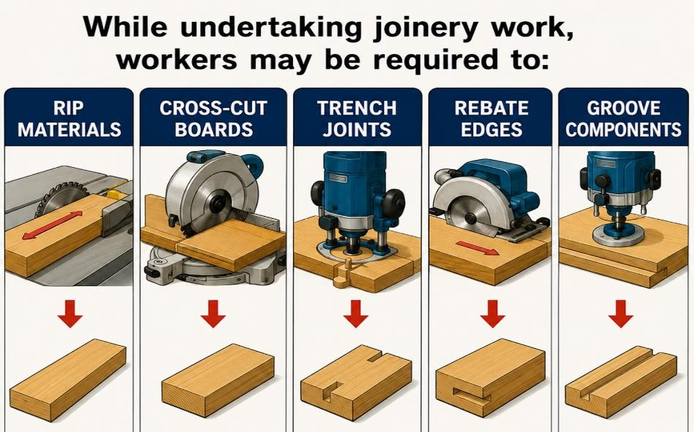
- rip materials
- cross-cut boards
- trench joints
- rebate edges
- groove components Workers must:
- support materials correctly
- maintain safe hand positions
- use correct blades
🔗 Using a Handsaw, Using a Circular Saw and Using a Jigsaw
In Section 3 practical observations, students must manufacture project components to the correct length and width.
STUDENT QUESTION
Why should materials be supported correctly during cutting?
Your Answer:

6.3 Drilling and Machining
Drilling and machining activities prepare components for hardware installation and assembly.
While undertaking joinery work, workers may be required to machine:
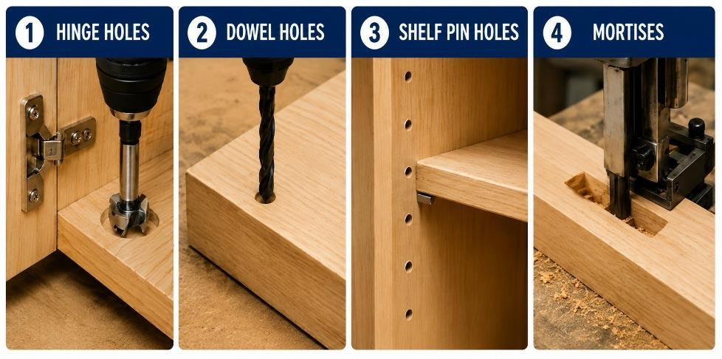
- hinge holes
- dowel holes
- shelf pin holes
- mortises
Machining accuracy is essential for:
- hardware alignment
- assembly quality
🔗 Using a Battery Drill
🔗 Using a Pedestal Drill
In Section 3 practical observations, students must use machinery to manufacture project component, which may include the morticing and/or pedestal drill.
For more detailed tools and machinery information refer to the Task 2 - Tools and Equipment - Teacher Guide.

6.4 Temporary Supports and Jigs
Jigs are devices or guides used to hold, position or support materials and tools accurately during manufacturing and assembly tasks.
Workers must ensure jigs are stable and correctly adjusted.
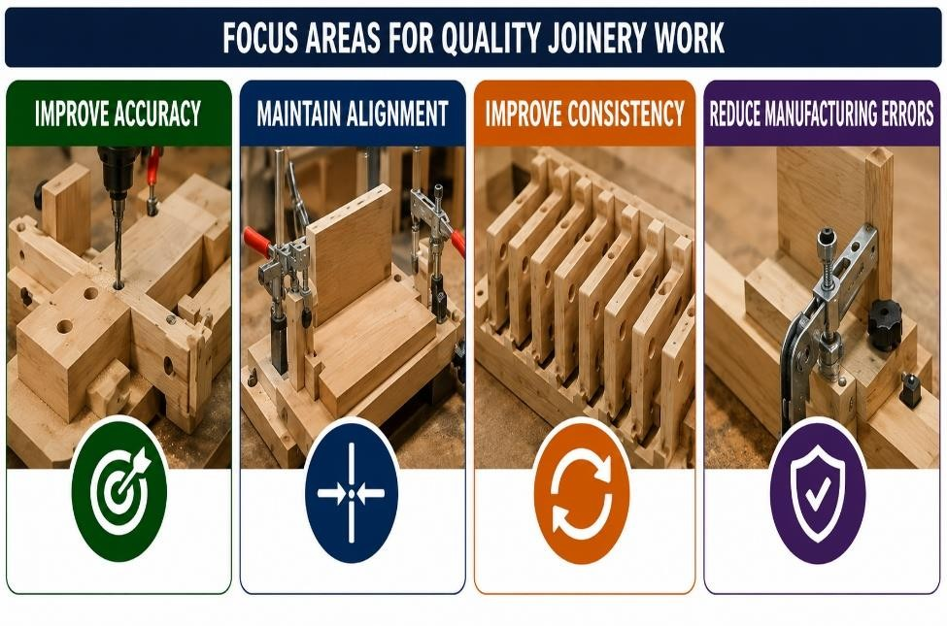
Jigs and temporary supports help:
- improve accuracy
- maintain alignment
- improve consistency
- reduce manufacturing errors

STUDENT QUESTION
What is the purpose of a jig?
Your Answer:

  - Edge Banding
Edge banding protects exposed board edges and improves the finished appearance of joinery
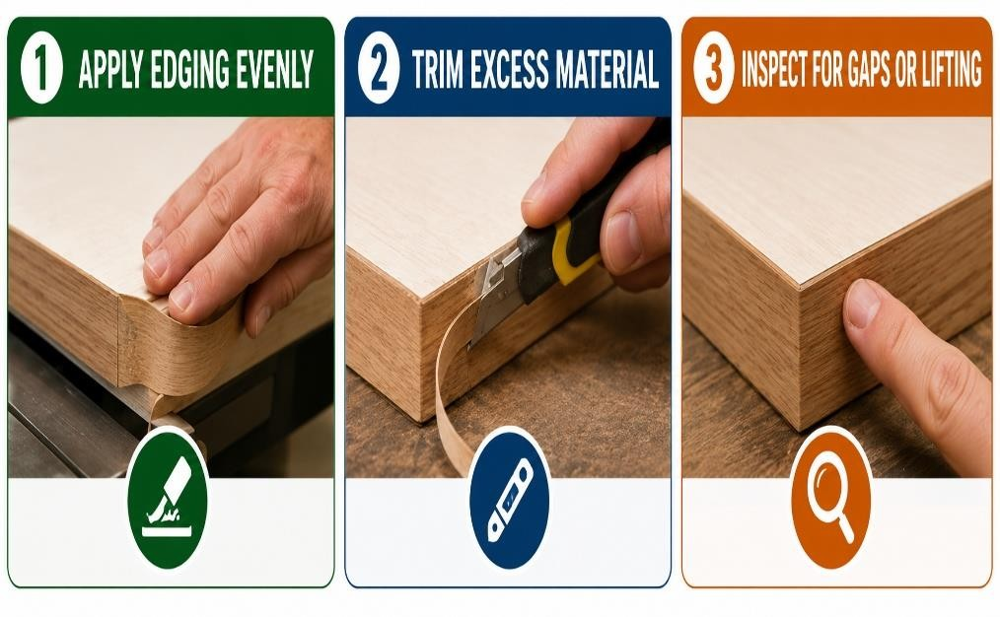
products.

Workers must:

•

apply edging evenly

•

trim excess material

•

inspect for gaps or lifting

🔗

Using an Edge
B
a
nde
r

  - Labelling Components
Components should be labelled clearly to assist assembly and identification during manufacturing.
While undertaking joinery work, workers should label components to identify:
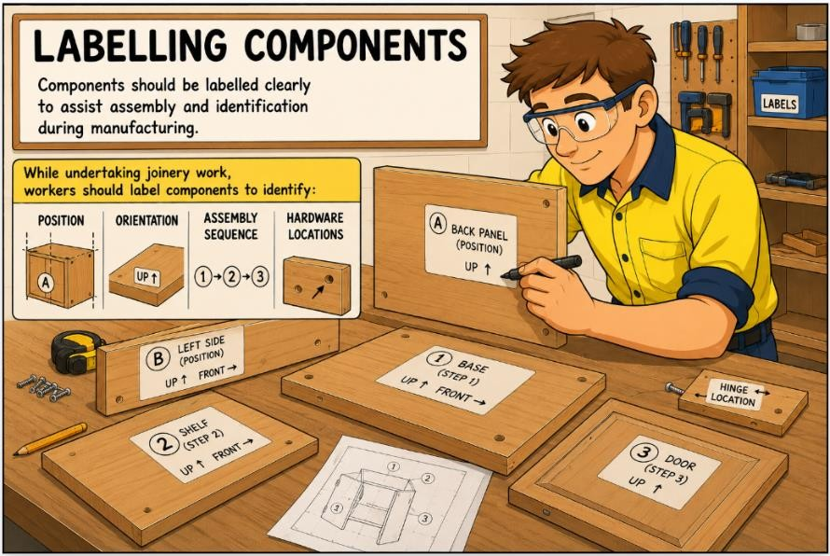
- position
- orientation
- assembly sequence
- hardware locations
Correct labelling reduces assembly errors.

CONSTRUCTION “TASK 5.3 – JOINERY” WORKBOOK — SECTION 7
Joinery Assembly Techniques
7.1 Common Joinery Project Assemblies
Joinery workers may manufacture and assemble a range of residential and commercial projects.

Projects may include:
- cupboards
- robe shelving
- countertops
- doors
- louvres
- window frames
- shopfronts
- stairs
Different projects require different:
- joints
- hardware
- assembly sequences
Task 5.3 – quiz questions assess a student’s ability to match various joinery units/projects to their assembly processes. In Section 3 practical observations, students must assemble each of their practical projects.

7.2 Dry Assembly Checks
Dry assembly checks help workers identify problems before permanent fixing begins.
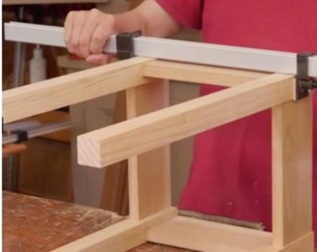
Before final fixing of joinery project components workers should:
- check fit
- inspect alignment
- check it is free from wind
- confirm squareness
- test hardware positions
In Task 5.3 –Section 3 practical observations, students must dry-assemble practical project components and check they conform with project plans and specifications.
STUDENT QUESTION
Why should materials be supported correctly during cutting?
Your Answer:

7.3 Common Joinery Joints
Different joinery joints are selected depending on strength, appearance and assembly requirements.
Common joints used in joinery work include:
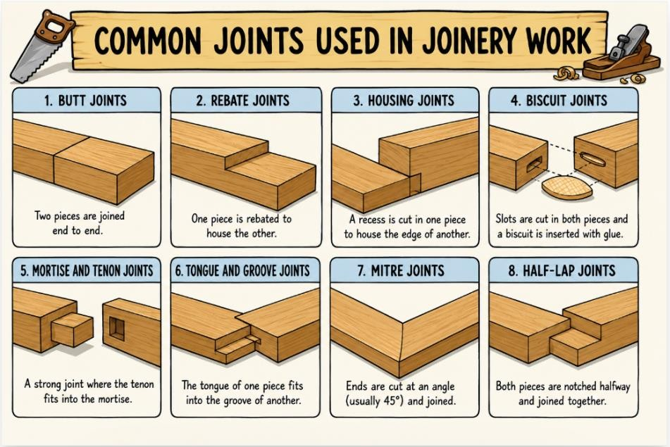
- butt joints
- rebate joints
- housing joints
- biscuit joints
- mortise and tenon joints
- tongue and groove joints
- mitre joints
- half-lap joints
Different joints provide different:
- strengths
- appearances
- assembly methods
🔗 Joinery Types
🔗 18 Types of Wood Joinery
Task 5.3 – quiz questions assess a student’s ability to match common timber joints to their purpose.

  - Mortise and Tenon Joints
Mortise and tenon joints are commonly used where strong timber connections are required.
Mortise and tenon joints are commonly used in:
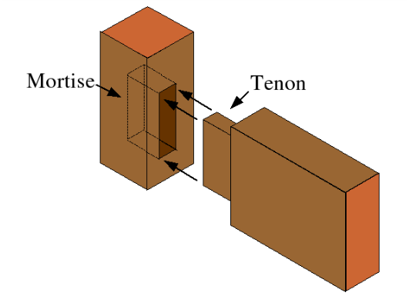
•

doors

•

frames

•

windows

Typical guidelines:

•

tenon thickness ≈ one
-
third of
timber thickness

•

shoulders square

•

snug fit

The tenon fits into the mortise to create a
strong mechanical connection.

🔗

Mortise and Teno
n

  - Assembly Methods
Joinery assemblies may use a range of fixing and joining methods depending on the project requirements.
Joinery project components may be assembled using:
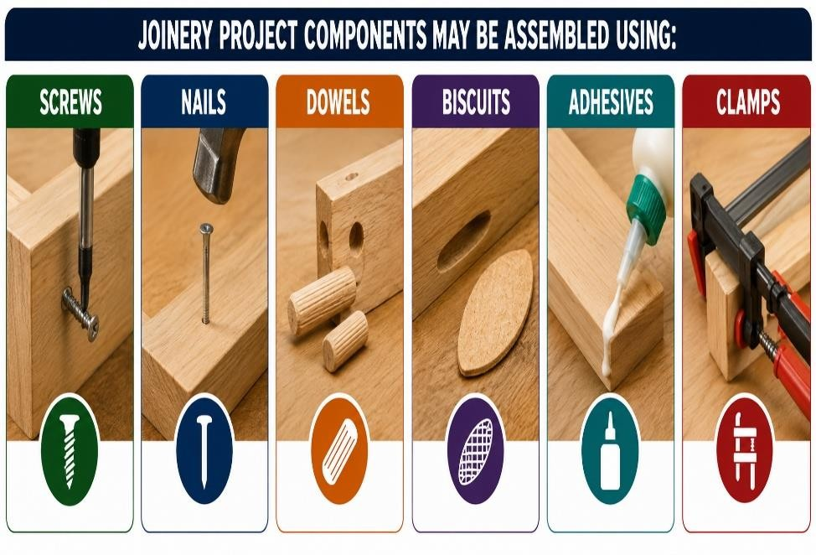
- screws
- nails
- dowels
- biscuits
- adhesives
- clamps Workers must:
- follow assembly sequences
- avoid damaging surfaces
- maintain alignment
In Task 5.3 –Section 3 practical observations, students must carefully assemble practical project components using adhesive, mechanical fasteners and holding systems.

7.6 Clamping Techniques
Clamps help maintain alignment and improve joint strength during assembly.
During the assembly of joinery project components, clamps help to:
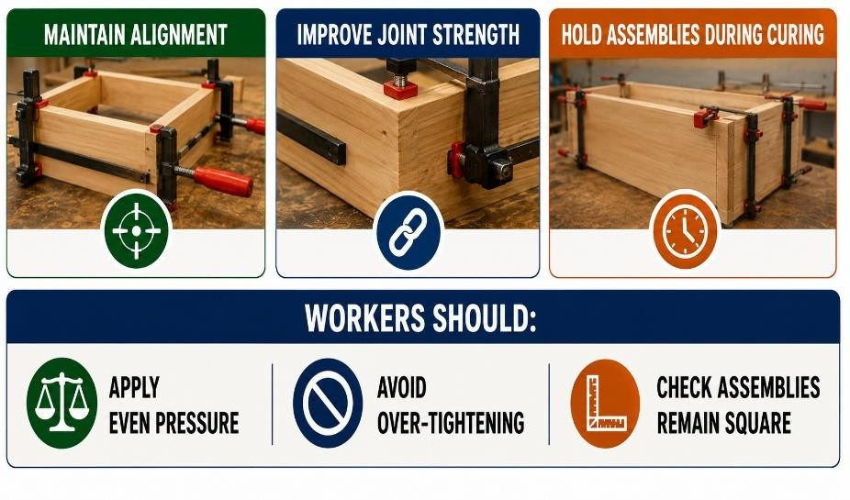
- maintain alignment
- improve joint strength
- hold assemblies during curing Workers should:
- apply even pressure
- avoid over-tightening
- check assemblies remain square
🔗 Woodworking Clamps 1 and 2
STUDENT QUESTION
Why should clamps not be over-tightened?
Your Answer:

7.7 Wind in Joinery Assemblies
“Wind” occurs when an assembly twists and corners become uneven.
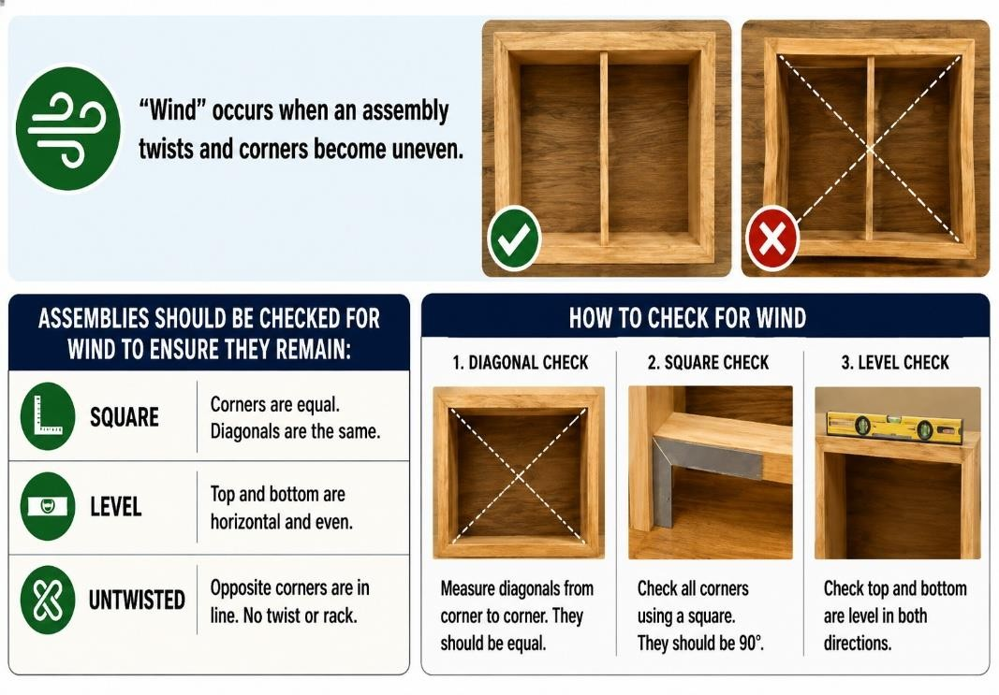
Assemblies should be checked for wind to ensure they remain:
- square
- level
- untwisted
Assemblies free from wind fit and operate correctly.

In Task 5.3 –Section 3 practical observations, students must conduct final quality checks on assembled practical projects, ensuring they are free from wind.
STUDENT QUESTION
Why should assemblies be checked for wind?
Your Answer:

7.8 Protecting Surfaces During Manufacture and Assembly
Finished surfaces should be protected throughout assembly activities to prevent damage.
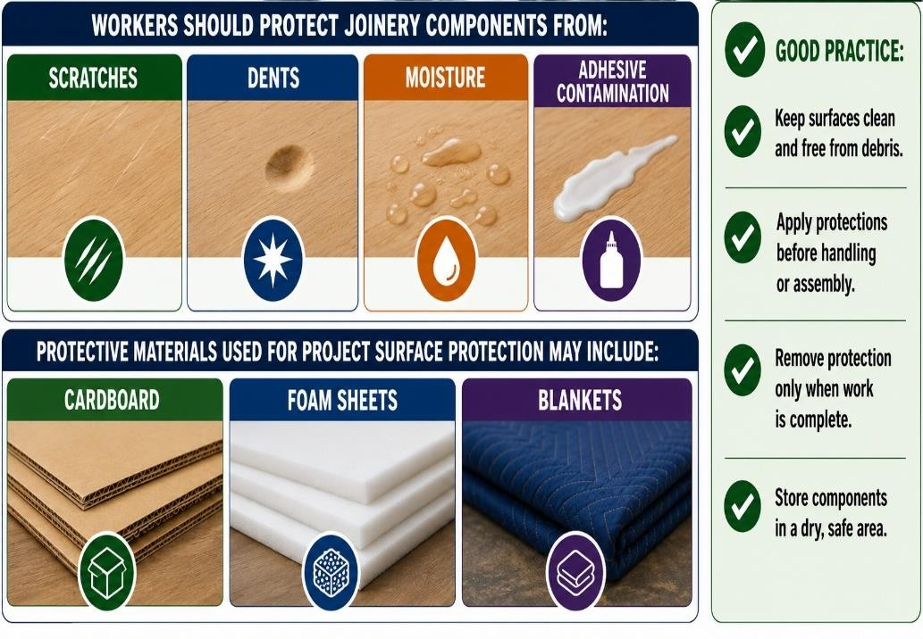
Workers should protect joinery components from:
- scratches
- dents
- moisture
- adhesive contamination
Protective materials used for project surface protection may include:
- cardboard
- foam sheets
- blankets
In Task 5.3 –Section 3 practical observations, students must use packing materials to protect practical project material surfaces during manufacture and assembly processes.
CONSTRUCTION “TASK 5.3 – JOINERY” WORKBOOK — SECTION 8
Assembly Processes
8.1 Door Assemblies
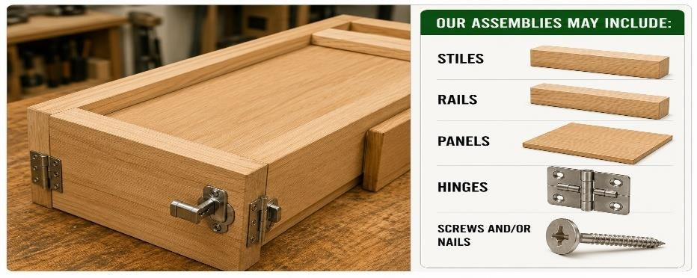
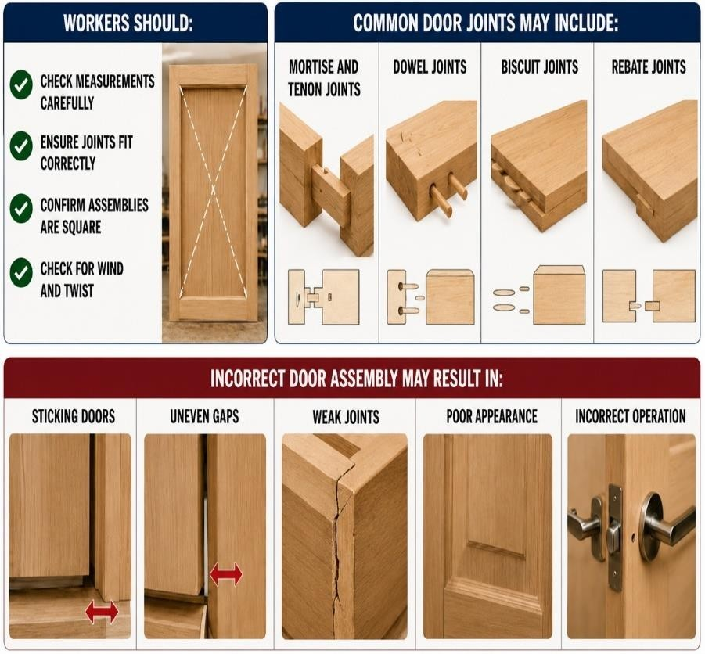
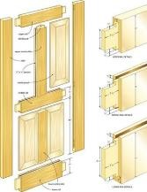
Door assemblies must be manufactured and assembled accurately to ensure correct fit, strength and smooth operation. Workers must follow plans and specifications carefully when preparing and assembling door components.
Door assemblies may include:
- stiles
- rails
- panels
- hinges
- locks and handles
Workers should:
- check measurements carefully
- ensure joints fit correctly
- confirm assemblies are square
- check for wind and twist
Common door joints may include:
- mortise and tenon joints
- dowel joints
- biscuit joints
- rebate joints
Incorrect door assembly may result in:
- sticking doors
- uneven gaps
- weak joints
- poor appearance
- incorrect operation
Workers may use:
- clamps
- framing squares
- adhesives
- screws
Completed assemblies should be inspected to ensure:
- squareness
- secure joints
- smooth surfaces
- correct dimensions
- correct hardware positioning
Task 5.3 – quiz questions assess a student’s ability to identify the correct door assembly processes. In Section 3 practical observations, students must produce a multi panelled door.
STUDENT QUESTION
Why must doors have correct clearances?
Your Answer:

.2 Door Frame and Jamb Assembly
Door frames and jambs must be assembled accurately to ensure doors fit correctly and operate smoothly. Workers must follow plans and specifications carefully when measuring, cutting and assembling frame components.
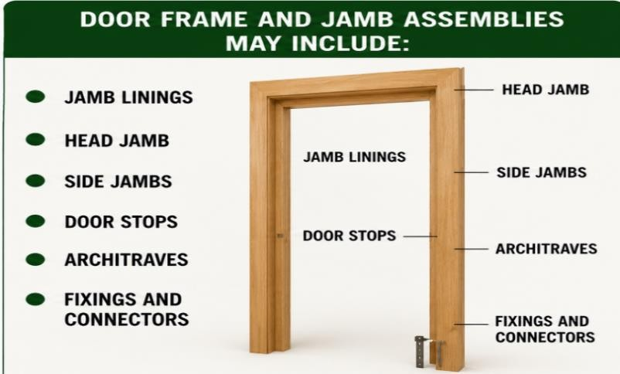
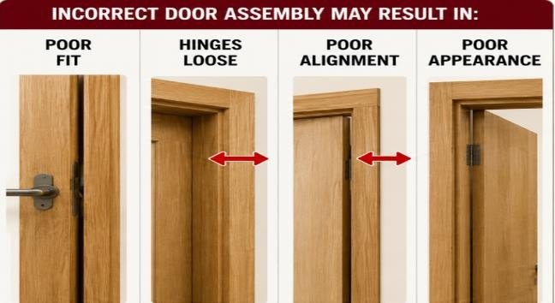
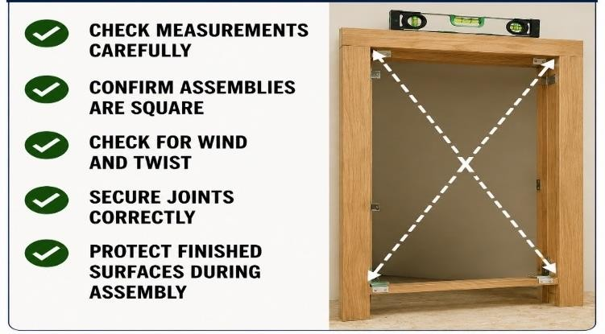
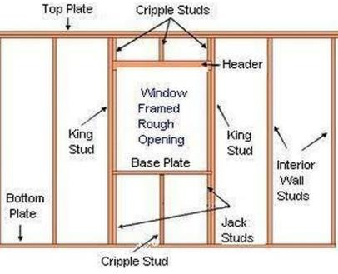
Door frame and jamb assemblies may include:
- jamb linings
- head and side jambs
- door stops
- architraves
- fixings and connectors
Workers should:
- check measurements carefully
- confirm assemblies are square
- check for wind and twist
- secure joints correctly
- protect finished surfaces during assembly
Incorrect frame assembly may result in:
- doors sticking
- uneven gaps
- poor alignment
- difficult installation
Workers may use:
- clamps
- framing squares
- temporary supports
- nail guns
- screws and adhesives
Completed assemblies should be inspected to ensure:
- squareness
- correct dimensions
- secure joints
- clean finishes
- correct operation clearance
🔗 Door Jamb Assembly, Door Jamb Install and Installing Door Frames and Doors
Task 5.3 – quiz questions assess a student’s ability to identify the correct door frame and jamb assembly processes. Section 3 practical observations, students must produce a door frame and jamb.
STUDENT QUESTION
Why must door frame assemblies remain square?
Answer:

.3 Cabinet Assemblies
Cabinet assemblies must be manufactured and assembled accurately to ensure strength, alignment and correct operation. Workers must follow plans, cutting lists and specifications carefully during cabinet assembly activities.
Cabinet assemblies may include:
- side panels
- shelves
- backs
- kickboards
- doors and drawers
- benchtops
- adjustable shelving
Workers should:
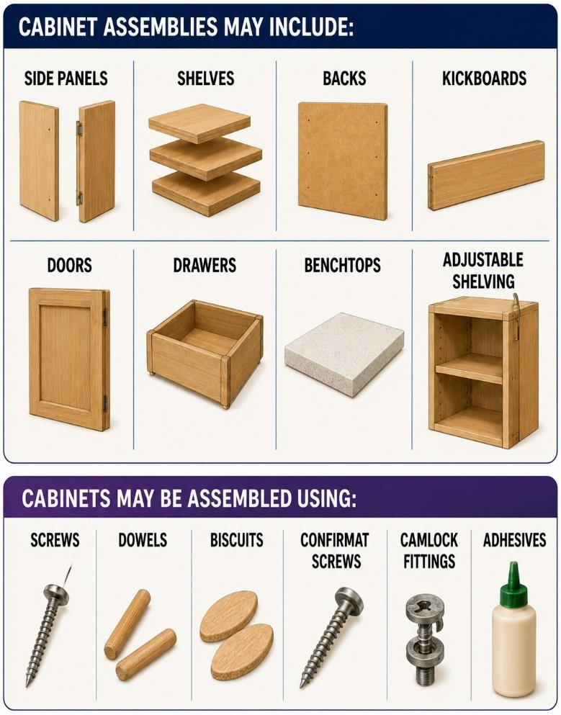
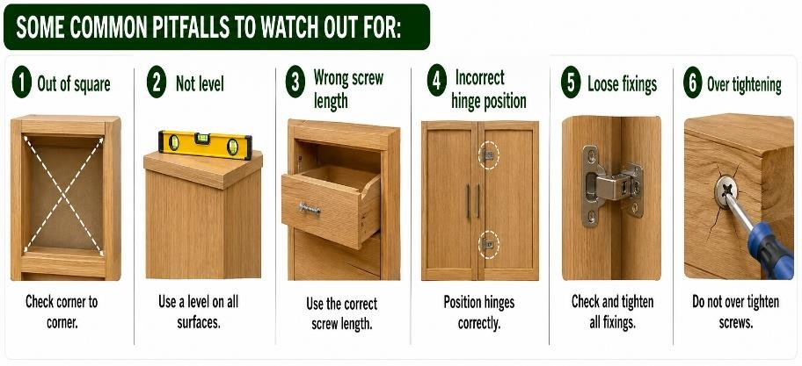
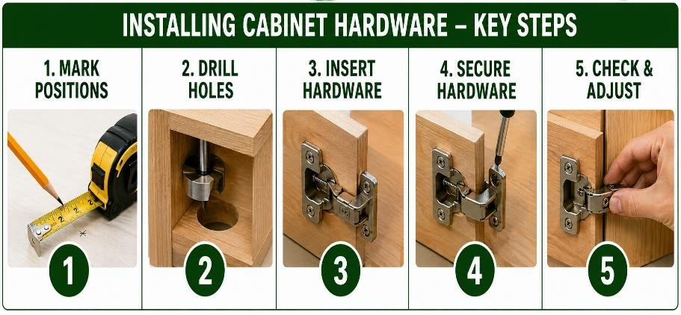
- confirm components are labelled correctly
- check assemblies remain square
- inspect hardware alignment
- secure joints correctly
- protect finished surfaces during assembly
Cabinets may be assembled using:
- screws
- dowels and biscuits
- confirmat screws
- camlock fittings
- adhesives
Incorrect cabinet assembly may result in:
- poor alignment
- weak joints
- uneven doors and drawers
- incorrect operation
- reduced strength
Workers may use:
- clamps
- assembly jigs
- framing squares
- drills
- screwdrivers
Completed cabinet assemblies should be inspected to ensure:
- squareness
- level surfaces
- smooth drawer operation
- correct door alignment
- secure fixings
- clean finishes
🔗 Cabinet Assembly, Cabinet Install and Flat Pack Assembly
Task 5.3 – quiz questions assess a student’s ability to identify the correct cabinet cupboard assembly processes. Section 3 practical observations, students must produce a cabinet carcass unit.

.4 Window Assemblies
Assembling windows is a common joinery work activity.
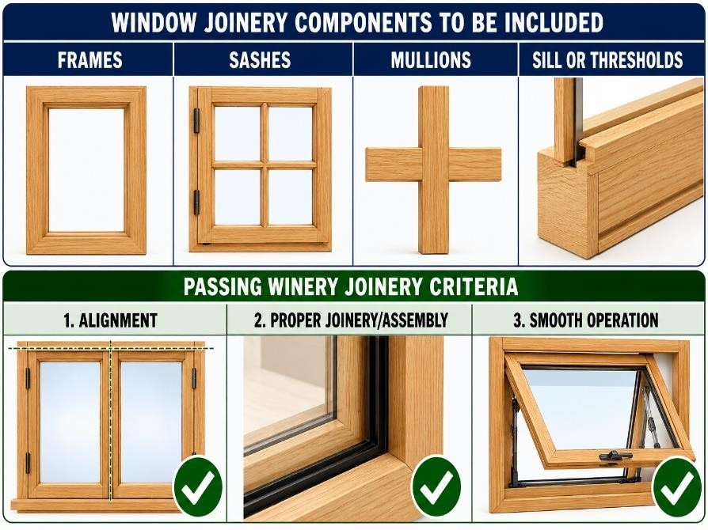
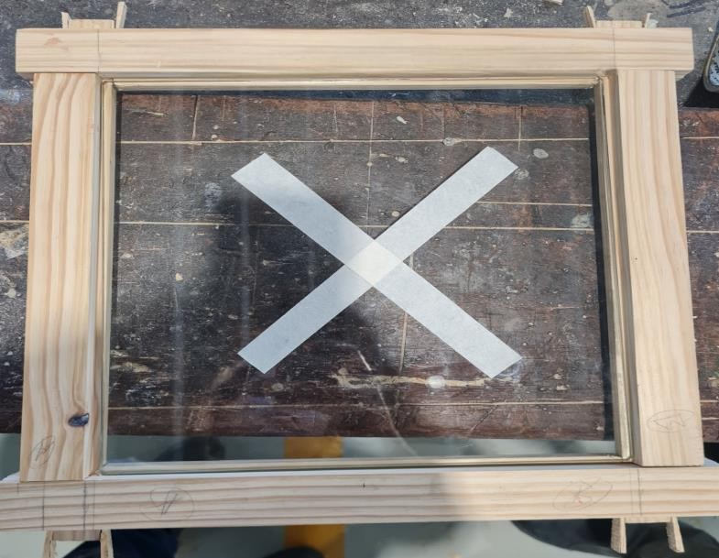
Window joinery components may include:
- frames
- sashes
- mullions
- glazing rebates or beads Typical assembly process:
- Measure and cut rails, stiles and glazing bars to length • Machine or cut mortise and tenon or housing joints
- Rout glazing rebates or grooves where required
- Dry assemble and check for square
- Apply construction adhesive to joints
- Clamp and secure components together
- Sand and finish the completed assembly
Common joint types:
- Through mortise and tenon
- Housing joints
- Rebated joints
Workers should check:
- alignment
- weather sealing areas
- smooth operation
🔗 Window Sash Assembly
Task 5.3 – quiz questions assess a student’s ability to identify the correct window assembly processes.

98.5 Countertop Joinery
Assembling countertops is a common joinery work activity.
Countertop joinery processes may include the use of:
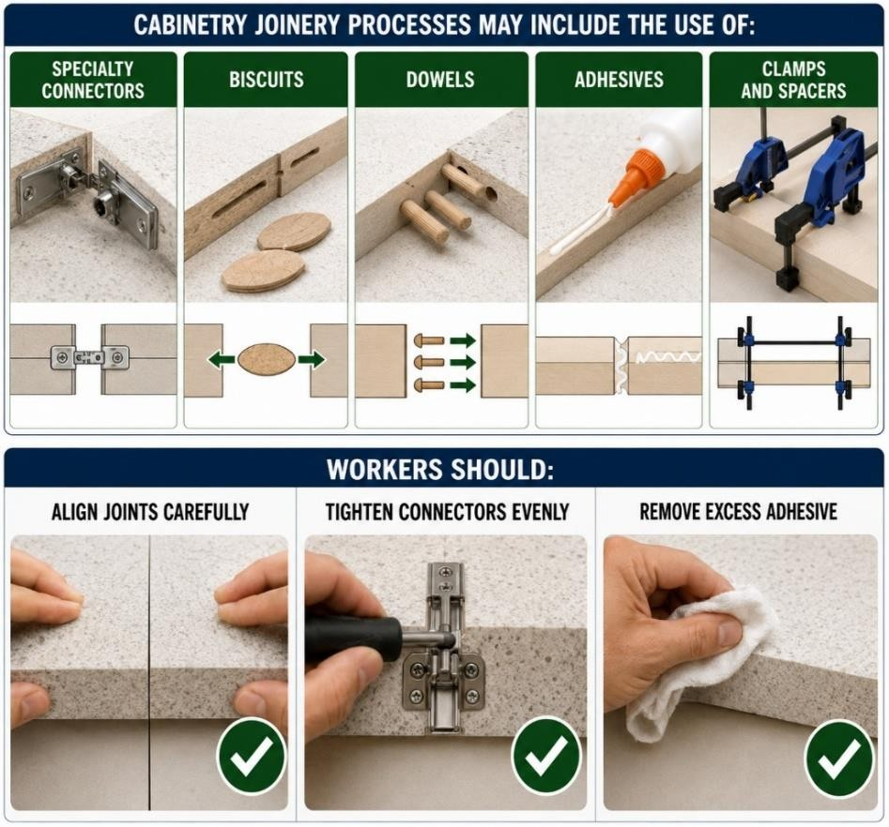
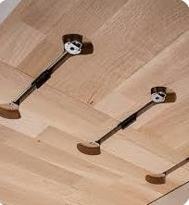
- benchtop connectors
- biscuits
- dowels
- adhesives
Typical assembly process:
- Cut benchtops to length
- Drill connector recesses
- Machine biscuit or dowel slots where required
- Dry fit and check alignment
- Apply adhesive
- Tighten benchtop connectors
- Clean excess adhesive and inspect the joint Common joint types:
- Butt joints
- Connector joints
- Biscuit joints
- Dowel joints Workers should:
- align joints carefully
- tighten connectors evenly
- remove excess adhesive
🔗 Countertop Assembly
Task 5.3 – quiz questions assess a student’s ability to identify the correct countertop assembly processes.

8.6 Stair Assemblies
Stair assemblies require accurate marking, cutting and joint preparation to ensure safe and structurally sound construction. Treads, risers and stringers must be assembled square and securely fixed.
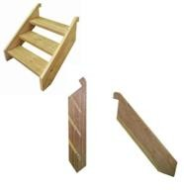
Typical assembly process:
- Set out tread and riser locations
- Mark and cut housing joints into stringers
- Measure and cut treads and risers
- Apply adhesive where required
- Clamp and screw components together
- Check for square and correct alignment
- Sand and finish the completed staircase Common joint types:
- Housing joints
- Through or wedged housing joints
Task 5.3 – quiz questions assess a student’s ability to identify the correct stair assembly processes.

8.7 Louvre Assemblies
Louvre assemblies consist of accurately spaced slats installed between rails and stiles. Precision machining is essential to ensure the louvres fit securely and maintain an even appearance.
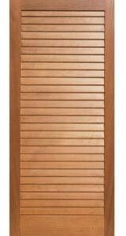
Typical assembly process:
- Cut rails and stiles
- Drill or rout louvre slots
- Machine housing joints
- Insert louvre blades
- Apply adhesive
- Clamp square
- Sand and finish Common joint types:
- Housing joints
- Mortise and tenon (frame)
Task 5.3 – quiz questions assess a student’s ability to identify the correct louvre assembly processes.

8.8 Shopfront Assemblies
Shopfront assemblies are large structural joinery systems designed to support glazing, doors and commercial entrances. Components are assembled accurately to ensure strength, weather resistance and correct installation.
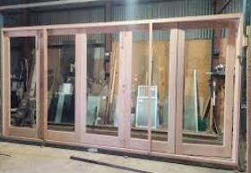
Typical assembly process:
- Measure and cut framing members.
- Assemble frame sections.
- Install glazing rebates.
- Check frame for square.
- Install glazing or door components.
- Secure and seal joints where required.
Common joint types:
- Mortise and tenon
- Housing joints
- Mechanical connectors
- Aluminium framing connections
Task 5.3 – quiz questions assess a student’s ability to identify the correct shopfront assembly processes.

CONSTRUCTION “TASK 5.3 – JOINERY” WORKBOOK — SECTION 9
Fasteners, Adhesives and Hardware
  - Fasteners
Fasteners are used to secure joinery components together during assembly.
Common fasteners used during the assembly of joinery project components include:
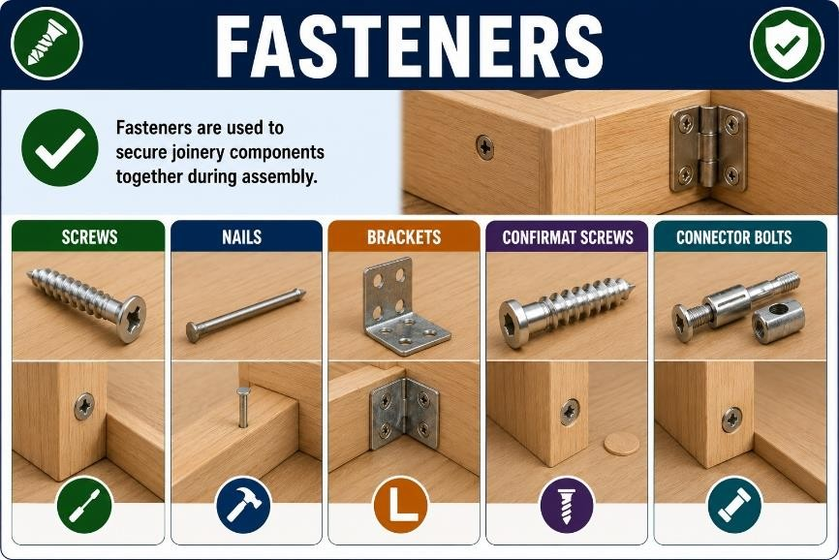
•

screws

•

nails

•

brackets

•

confirmat screws

•

connector bolts

Fasteners should suit:

•

material type

•

load requirements

•

appearance

🔗

Fasteners for Cabinet Makin
g

  - Adhesives
Adhesives strengthen joints and bond materials together.
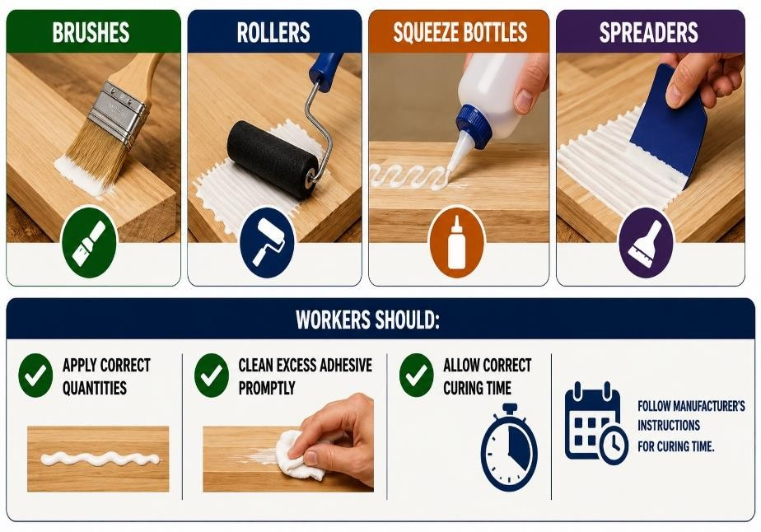
Workers may be required to apply adhesives using:
- brushes
- rollers
- squeeze bottles
- spreaders Workers should:
- apply correct quantities
- clean excess adhesive promptly
- allow correct curing time
🔗 Adhesive Strength and Applying Contact Adhesive
In Task 5.3 –Section 3 practical observations, students must carefully assemble practical project components using adhesive, mechanical fasteners and holding systems.
STUDENT QUESTION
Why should excess adhesive be cleaned promptly?
Your Answer:

9.3 Adhesive Safety
Workers must handle adhesives safely to reduce health and safety risks.
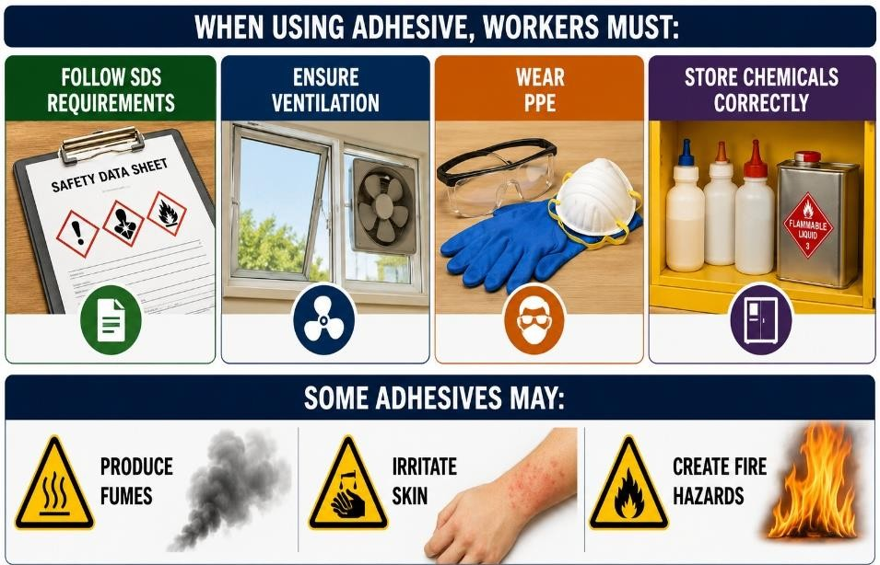
When using adhesive, workers must:
- follow SDS requirements
- ensure ventilation
- wear PPE
- store chemicals correctly Some adhesives may:
- produce fumes
- irritate skin
- create fire hazards
🔗 Adhesive SDS

9.4 Hardware Positioning
Hardware must be positioned accurately to ensure correct operation and appearance.
During the assembly of joinery project components, hardware must be:
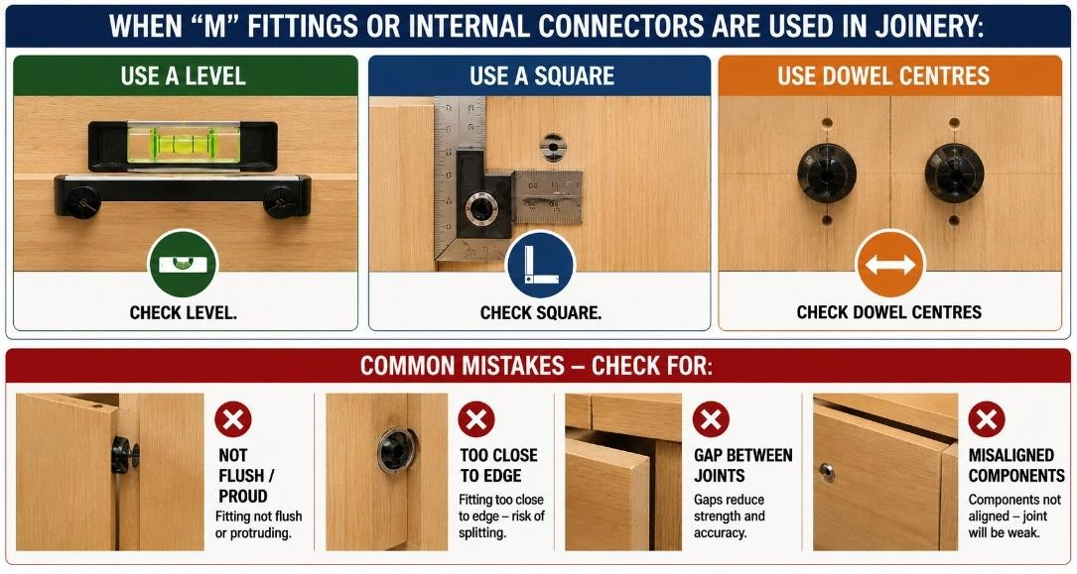
- level
- square
- aligned correctly
Incorrect positioning may:
- affect operation
- damage components
- reduce quality

STUDENT QUESTION
Why must hardware be aligned correctly?
Your Answer:

9.5 Knockdown Fittings
Knockdown fittings can be a fast and efficient way to assemble joinery components.
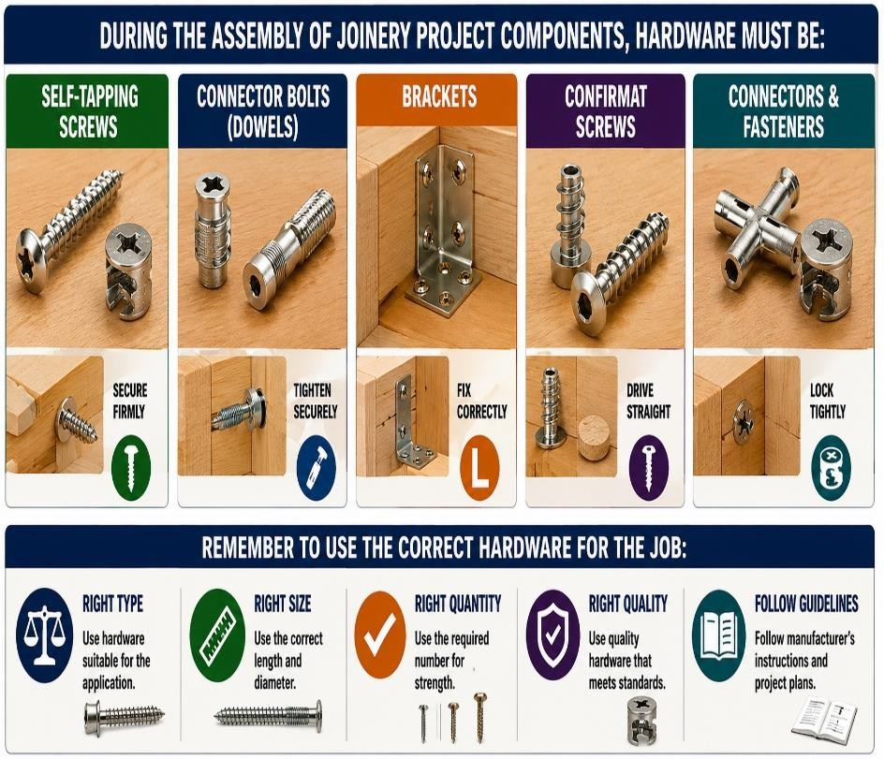
Common knockdown fittings include:
- camlock fittings
- insert nuts and bolts
- concealed hinges
- benchtop connectors
- cross dowels
These fittings are commonly used in:
- flat-pack cabinetry
- cupboards
- shelving systems
🔗 Knockdown Fittings Video
🔗 Knockdown Fittings Guide 1 and 2
Task 5.3 – quiz questions assess a student’s ability to identify common knockdown fittings and their description.
STUDENT QUESTION
What are knockdown fittings commonly used for?
Your Answer:

CONSTRUCTION “TASK 5.3 – JOINERY” WORKBOOK — SECTION 10
Quality Checks, Packaging and Finishing
10.1 Quality Assurance and Quality Control
Quality checks and inspection procedures help ensure completed joinery products meet workplace standards, operate correctly and are free from defects.
Quality Assurance
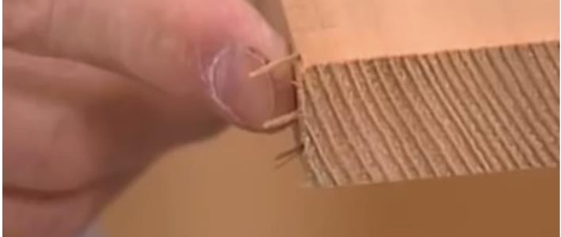
Processes used to maintain consistent product quality.
Quality Control
Inspection activities used to identify defects and faults.
Quality Improvement
Changes made to improve manufacturing outcomes.
Workers should inspect products regularly during manufacturing and assembly.
Task 5.3 – quiz questions assess a student’s ability to identify project quality control check processes and terminology. In Section 3 practical observations, students must undertake quality checks of project materials and components.
STUDENT QUESTION
What is the purpose of quality control?
Your Answer:

10.2 Final Inspection
Completed joinery products should be inspected carefully before handover or installation.
After the assembly of joinery project components is complete, workers should inspect project:
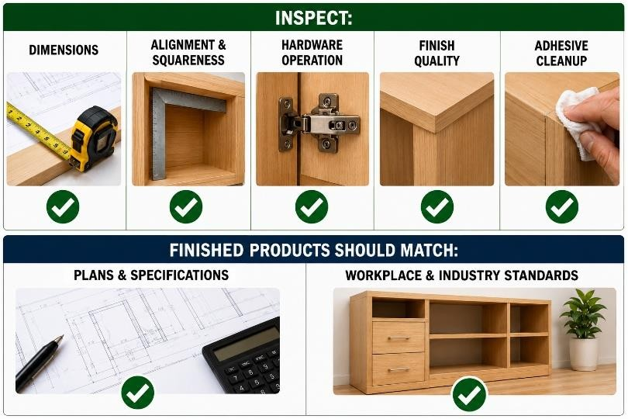
- dimensions
- alignment and squareness
- hardware operation
- finish quality
- adhesive cleanup
Finished products should match:
- plans and specifications
- workplace and industry standards
In Section 3 practical observations, students must conduct a final quality check on the 3 designated joinery practical projects, ensuring they accurately conform with the project plans and specifications.

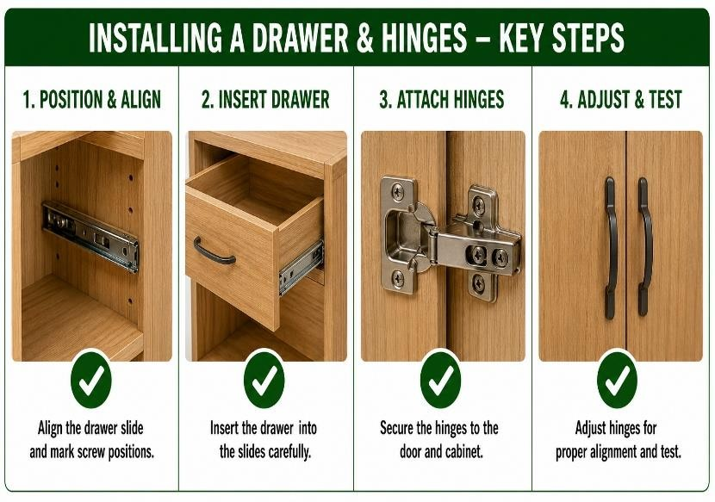
10.3 Operational Testing
Operational testing ensures moving components function correctly and safely.
After the assembly of joinery project components is complete, workers should test:
- door movement
- drawer operation
- hinge alignment
- smooth opening and closing
STUDENT QUESTION
Why should finished products be inspected operationally carefully against plan specifications?
Your Answer:

10.4 Surface Protection, Packaging and Storage
Finished surfaces should be protected from damage during storage, transport and installation. Finished products should be packaged and stored carefully to maintain quality and prevent damage.
Finished joinery should be protected from:
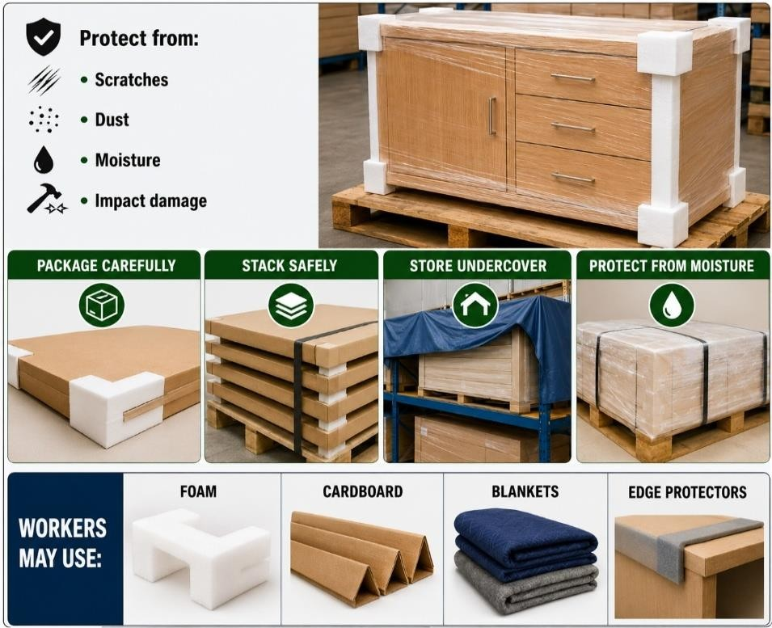
- scratches and impact damage
- dust and moisture
Finished products should be:
- packaged carefully
- stacked safely
- stored undercover
- protected from moisture Workers may use:
- foam
- cardboard
- blankets
- edge protectors
In Task 5.3 –Section 3 practical observations, students must carefully package and stack assembled practical projects to protect edges and surfaces from damage.
STUDENT QUESTION
Why should finished products be protected during storage?
Your Answer:

CONSTRUCTION “TASK 5.3 – JOINERY” WORKBOOK — SECTION 11
Cleaning, Storage and Waste Management
11.1 Cleaning Work Areas
Clean work areas improve safety, organisation and productivity within joinery workshops.
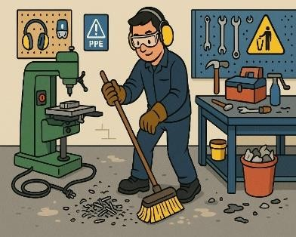
After joinery project processes are complete, workers should:
- sweep floors and remove dust
- clean machinery
- dispose of waste materials
Good housekeeping reduces hazards.
In Task 5.3 –Section 3 practical observations, students must clean the work area and dispose of materials used during practical project production activities.

11.2 Cleaning and Maintaining Tools
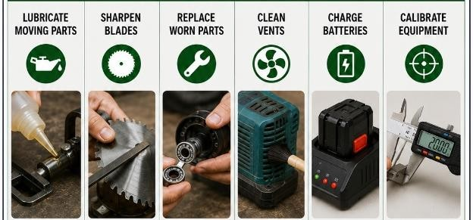
Regular cleaning and maintenance help tools and machinery operate safely, accurately and efficiently. After joinery project tool, equipment and machinery processes are complete, maintenance may include:
- lubricating moving parts
- sharpening blades
- replacing worn parts
- cleaning vents
- charging batteries
- calibrating equipment
🔗 Cleaning Saw Blades, Tool Care and Tool Care Video
Workers should report faulty tools and machinery to supervisors.
In Task 5.3 –Section 3 practical observations, students must clean, check, maintain machinery, tools and equipment used during practical project production activities.

11.3 Storing Tools and Equipment
Tools and equipment should be stored safely after use to reduce damage and workplace hazards.
After joinery project tool, equipment and machinery processes are complete, workers should:
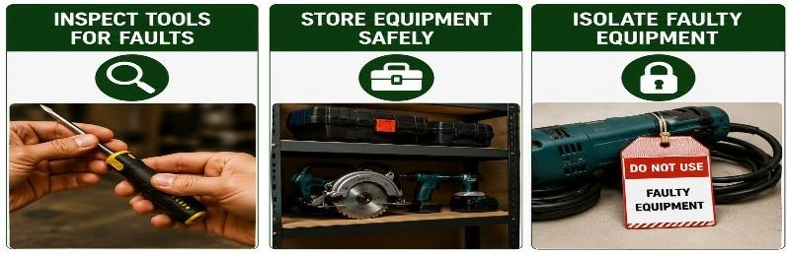
- inspect tools for faults
- isolate faulty equipment
- place tools in designated storage areas

In Task 5.3 –Section 3 practical observations, students must store tools and equipment used during practical project production activities.

  - Waste Minimisation
Workers should minimise waste to improve efficiency and reduce environmental impacts. Before, during and after joinery project processes are completed, workers should:
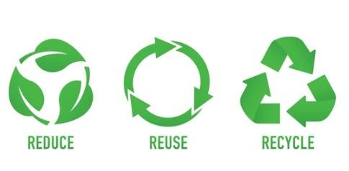
•

plan cuts carefully

•

reuse offcuts

•

recycle materials

•

minimise waste

Good waste management:

•

reduces costs

•

improves sustainability

  - Environmental Controls
Environmental controls help reduce the impact of joinery activities on the workplace and surrounding environment.
During and after joinery project processes are completed, workers should:
- control dust
- reduce noise
- separate waste materials
- store chemicals safely
The NSW EPA (Environment Protection Authority) is the primary environmental regulator in New South Wales. The EPA helps protect the environment by regulating issues such as:

- waste disposal
- pollution
- dust control
- noise management
- hazardous substances
- stormwater contamination
Construction and joinery workers must follow workplace environmental procedures and EPA requirements to reduce environmental impacts during work activities.
🔗 EPA - guidelines on reporting in NSW
🔗 Search Results | EPA
Task 5.3 – quiz questions assess a student’s ability to identify the EPAs purpose.
STUDENT QUESTION
Why is housekeeping important in joinery workshops?
Your Answer:

